# Project Overview

## Subject Matter Experts

This list includes subject matter experts (SMEs) identified during background research. Inclusion here does **not** imply involvement in or endorsement of this project. Only individuals who explicitly agreed to go on record are cited in the final report. This list is preserved solely for internal reference.

City of Fort Worth **IT Solutions manager - Stever Vandever**  
**Dataset owner - Mark DeBoer**  
**Senior Plans Examiner - Giselle Gonzales:**   
**Economic Development Manager – Michael Hennig, CEcD  
  
Contact Info:** <https://www.fortworthtexas.gov/departments/city-directory>  
**IT Department Info:** <https://www.fortworthtexas.gov/departments/it-solutions>   
  
Fort Worth Economic Development Partnership  
**Associate – Katie McConnell**   
**Contact Info:** <https://fortworthedp.com/contact/>

## Permitting Process

Process charts are published here: <https://www.fortworthtexas.gov/departments/development-services/process/process-charts>   
  
The two most relevant to reference are:  
1. [Master Development Process Chart](https://www.fortworthtexas.gov/files/assets/public/development-services/documents/applications-forms/p/master-process-chart-2023.pdf)  
2. [Building Permit Process Chart](https://www.fortworthtexas.gov/files/assets/public/v/1/development-services/documents/resources-applications-forms-videos/p/building-permit-chart-2023.pdf)

## Business Software

The city of Fort Worth uses a software solution called “Accela”: <https://www.accela.com/about/>

There is a public search feature, where you can search by address ranges, and internally, addresses are used to identify which project a permit belongs to. See: [Example search](https://aca-prod.accela.com/CFW/Cap/CapDetail.aspx?Module=Development&TabName=Development&capID1=21DEV&capID2=00000&capID3=004ED&agencyCode=CFW&IsToShowInspection=)

Research sources

The following is a list of sources I referenced while researching for this project. The majority contain information that I used in the final report, while others informed some of my understanding of the history and indirectly shaped the analysis, and still others I found relevant but did not reference enough to count them as “sources” in the strict sense, but included them to make the list comprehensive for any others who are looking into these topics themselves (including me in the future).

* **City of Fort Worth:**
  + **FW Permits:** <https://data.fortworthtexas.gov/Development-Infrastructure/Development-Permits/quz7-xnsy/about_data>
  + **COFW Economic Development Strategic Plan:** <https://www.fortworthtexas.gov/departments/econdev/edplan>
    - **Full Plan (2017):** <https://www.fortworthtexas.gov/files/assets/public/v/4/ecodev/documents/strategic-plan/strategic-plan-complete.pdf>
    - **Plan Update (2022):** <https://www.fortworthtexas.gov/files/assets/public/v/2/ecodev/documents/strategic-plan/updates/2022-strategic-plan-update.pdf>
  + **Fort Worth ISD Strategic Plan (2025):** <https://www.fwisd.org/about/strategic-plan>
  + **COFW 2023 Adopted Comprehensive Plan:** <https://www.fortworthtexas.gov/departments/the-fwlab/planning/comprehensiveplan/adopted>
  + **Fort Worth Public Library Digital Archives:** <https://www.fortworthtexasarchives.org/>
  + **City of Fort Worth website – Population:** <https://www.fortworthtexas.gov/about/population>
  + **City of Fort Worth website – History:** <https://www.fortworthtexas.gov/about/history>
* **Other Gov sites:** 
  + **U.S. Department of State's Office of the Historian - The Annexation of Texas, the Mexican-American War, and the Treaty of Guadalupe-Hidalgo, 1845–1848:** <https://history.state.gov/milestones/1830-1860/texas-annexation>
  + **The Alamo .org, Revolution Timeline:** <https://www.thealamo.org/remember/battle-and-revolution/revolution-timeline>
  + **US Library of Congress – Railroads in the Late 19th Century:** <https://www.loc.gov/classroom-materials/united-states-history-primary-source-timeline/rise-of-industrial-america-1876-1900/railroads-in-late-19th-century/>
  + **US National Archives and Records Administration (NARA) - National Interstate and Defense Highways Act (1956):** <https://www.archives.gov/milestone-documents/national-interstate-and-defense-highways-act>
  + **Fort Worth Botanic Garden website – About Us:** <https://fwbg.org/about-us/>
  + **U.S. Department of State – U.S. Relations With Mexico:** <https://www.state.gov/u-s-relations-with-mexico/>
* **Articles/news stories:**
  + **Fox 4 KDFW - Fort Worth's Race and Culture Task Force: Progress has been made but still room for improvement (2023-09-19):** <https://www.fox4news.com/news/fort-worths-race-and-culture-task-force-progress-has-been-made-but-still-room-for-improvement>
  + **ABC News – “Cities fear an economic doom loop as offices sit empty” (2024):** <https://www.youtube.com/watch?v=w4LOqOSi6Tk>
  + **KERA News - Fort Worth council finalizes decision to hire Jay Chapa as city manager amid controversy (2024-12-11):** <https://www.keranews.org/news/2024-12-11/fort-worth-council-finalizes-decision-to-hire-jay-chapa-as-city-manager-amid-controversy>
  + **Nobel Prize Press Release (2024):** <https://www.nobelprize.org/prizes/economic-sciences/2024/press-release/>
  + **Bloomberg Television YouTube Channel – The Erosion of US Statistical Data | Wall Street Week:** <https://www.youtube.com/watch?v=csCCzvLhMlI>
  + **D Magazine – Who Runs Fort Worth? (Nov, 1 1995):** <https://www.dmagazine.com/publications/d-magazine/1995/november/power-who-runs-fort-worth/>
  + **Last Week Tonight – Mass Deportations (2024):** <https://youtu.be/0UEhMDAlX1Y?si=EDTG9x5lKm79AqP9>
  + **The Hustle YouTube Channel – The Real Reason You Can’t Buy A House (2025):** <https://youtu.be/VryFaFsKhVE?si=V1jhf790zkN1uE_5>
  + **Fort Worth Report - Fort Worth sought to attract investment in new health care startups. Here are the results:** <https://fortworthreport.org/2024/12/15/fort-worth-sought-to-attract-investment-in-new-health-care-startups-here-are-the-results/>
  + **Texas Monthly - How Leaders of the Texas Revolution Fought to Preserve Slavery:** <https://www.texasmonthly.com/being-texan/how-leaders-texas-revolution-fought-preserve-slavery/>
* **Other webpage sources:**
  + **Britannica – American Civil War:** <https://www.britannica.com/event/American-Civil-War>
  + **Fort Worth Stockyards – History:** <https://www.fortworthstockyards.org/history>
  + **Texas State Historical Association – Handbook of Texas – Fort Worth:** <https://www.tshaonline.org/handbook/entries/fort-worth-tx>
  + **Texas State Historical Association – Handbook of Texas – Cattle Trailing:** <https://www.tshaonline.org/handbook/entries/cattle-trailing>
  + **Texas State Historical Association – Handbook of Texas – Neiman Marcus:** <https://www.tshaonline.org/handbook/entries/neiman-marcus>
  + **Wikipedia – Cattle Drives in the United Sates:** <https://en.wikipedia.org/wiki/Cattle_drives_in_the_United_States#Cattle_drive_era>
  + **Wikipedia – American Civil War:** <https://en.wikipedia.org/wiki/American_Civil_War>
  + **Texas Wesleyan website - Texas Wesleyan History:** <https://txwes.edu/about/university-history/>
  + **DFW Airport website – Facts:** <https://www.dfwairport.com/business/about/facts/>
* **Interviews with public figures:**
  + **The Fort Podcast - #9: Mayor Betsy Price - Small Business Growth in Fort Worth(2019-01-02):** <https://www.thefortpod.com/9-mayor-betsy-price-small-business-growth-in-fort-worth/>
  + **The Fort Podcast - #367 - Robert Allen - CEO @ Fort Worth Economic Development Partnership - Fort Worth, TX Is About to Explode With Growth (2024-10-08):** <https://www.thefortpod.com/367-robert-allen-ceo-fort-worth-economic-development-partnership-fort-worth-tx-is-about-to/>
  + **817 Podcast – Fort Worth’s Monday Morning Show - Behind Closed Doors: Chris Nettles Speaks Out on Fort Worth’s City Manager Search (2024-12-09):** <https://open.spotify.com/episode/5qNlx3qisVqueQOL47yDBf>
* **Books**
  + **¿Y ahora qué? México ante el 2018:** <https://www.amazon.com.mx/ahora-qu%C3%A9-M%C3%A9xico-ante-2018-ebook/dp/B077VY1P1N>
* **Museums**
  + **Cowtown takes flight (2024)**
    - **Webpage:** <https://www.fwmuseum.org/news/press-releases/cowtown-takes-flight-with-new-exhibit/>
    - **Educator Guide:** <http://www.fwmuseum.org/wp-content/uploads/2023/11/Cowtown-Takes-Flight-Educator-Guide.pdf>
  + **Cattle Raisers Museum (2024)** 
    - **Webpage:** <https://www.fwmuseum.org/cattle-raisers-museum/>
    - **Educator Guide:** <http://www.fwmuseum.org/wp-content/uploads/2023/11/Cattle-Raisers-Museum-Educator-Guide.pdf>
* **YouTube and general podcasts:**
  + **Biography YouTube Channel - Neiman Marcus: Last Of The Merchant Kings | Full Documentary | Biography :** <https://www.youtube.com/watch?v=sp3wuvwS9qU>
  + **Wisecrack YouTube Chanel – “What happens if the economy grows forever” (2025):** <https://www.youtube.com/watch?v=n5eb6vMfcSA>
  + **Economics Explained YouTube Channel – The 2024 Nobel Prize in Economics: Explained:** <https://youtu.be/P60TX-dwd4s?si=JoGcxqbOZxppharF>
  + **The Empire podcast:** <https://open.spotify.com/show/0sBh58hSTReUQiK4axYUVx>
  + **Stuff You Should Know Podcast – A Brief History of Air Travel:** <https://www.youtube.com/watch?v=f4CGIraAX7Q>
  + **Stuff You Should Know Podcast – Henry Ford: The Good, Bad and Ugly:** <https://www.youtube.com/watch?v=v9HUfy3Aqq8>
  + **Odd Lots – How Brazil gave birth to one of the world’s greatest jet makers:** <https://open.spotify.com/episode/1gQswy6G75WS0C7l4gRR52?si=nWrBCRNrTcOokQH27zD8ew>
  + **Latino USA – The U.S. and Mexico: A Complicated Relationship:** <https://www.latinousa.org/2025/03/02/acomplicatedrelationship/>

# Research Notes

## COFW Economic Development Strategic Plan (2017)

### 2024-10-30

#### Daily Summary

It seems like in 2017, a consulting firm determined the priorities for Fort Worth should be to enhance its medical district, and make use of its available land and infrastructure to attract and retain large “entrepreneurial” companies and tech companies alike. Much ado was made about creating the talent to entice these companies. This aiding the effort to reduce reliance or residential taxes and create more commercial tax revenue for the city.

And, as a necessary part of wanting to attract more medical, Aerospace, and tech business, the importance of attracting highly skilled and highly paid residents was emphasized, as well as the need to develop Downtown and other “Key” areas, presumably to drive ancillary development and business that would result from a bunch of workers being concentrated and spending a lot of their time in that area.

TIP lead the research efforts, enlisting help from JLL and others.

#### Notes

* *“The city’s growth in recent years has largely been defined by expansion of single-family residential development driven by employment growth in other cities.”*
* *“The threats facing the city may not always be apparent but they are very real. Recent business relocations, an increase in population not matched by an increase in wages, an out-of-balance tax base, and persistent difficulties in attracting skilled and educated young people—these issues risk engulfing Fort Worth.”*
* *“To address this challenge, the City of Fort Worth chose to devise its first ever economic development strategic plan. Working with TIP Strategies (an economic development consulting with offices in Austin and Seattle) and their partners (Fregonese Associates, JLL, and Isaac Barchas), the City of Fort Worth has engaged the business community and local stakeholders to create a strategic framework to guide the City’s economic development activities.”*
* *“RESULTS. The economic development strategic plan that emerged has very specific outcomes: 1. High-wage job growth. 2. A more sustainable tax base, driven less by residential property valuation and more by commercial and industrial investment. 3. An economy that capitalizes on high-growth businesses and the creative individuals who fuel them. 4. A commitment to “quality of place” throughout the community.”*
* Volumes 1-3 have unabridged appendixes with all research undertaken in different phases.
* TIP consulting drove this effort, engaging JLL (site selection perspective) and other consultants.
* *“A number of Fort Worth’s existing sectors and emerging opportunities will require STEM talent, which is currently lacking in the region”*
* *“The transportation and warehousing sector is the city’s largest in terms of its share of total employment”*
* *“Institutions of higher education in Tarrant County are a key component of the region’s talent pipeline and are essential for the city’s future success in growing high-wage jobs and attracting high-growth businesses”*
* 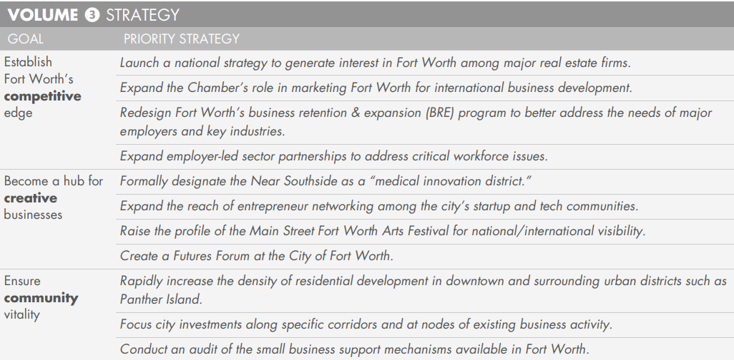
* *“The June 2017 announcement of XTO Energy’s relocation of 1,600 jobs from Fort Worth to the new Exxon campus in The Woodlands (just outside Houston) illustrates the need for a strong, proactive business retention and expansion (BRE) program. As soon as the firm was acquired by Exxon, the alarm bells should have been rung about the firm’s potential to vacate Fort Worth. Similar concerns need to be taken seriously in light of Williamson Dickie’s recent acquisition by VF Corporation. These examples illustrate the need for the City’s economic development program to strengthen its understanding of the requirements of local businesses.”*
* *“Access to a skilled workforce consistently ranks at or near the top of the list of site selection factors ranked in Area Development’s Annual Survey of Corporate Executives. The Dallas-Fort Worth metro area consistently attracts new business expansion projects that create thousands of new jobs on a monthly basis. Some of these new jobs will be filled by workers moving into the area from outside of the region and state, but the majority will be filled by local talent. This places the burden on communities in the region to develop a pipeline of talent to support the area’s rapidly expanding economy.”*
* *“What Fort Worth and the entire metro area lack is a robust networking environment for local entrepreneurs and tech workers. In fact, the only city in Texas that does this well is Austin.”*
* *“Public investments in economic development must be made only when they can reasonably be expected to generate economic benefits. The City must play a lead role as a strategic investor to catalyze development in neighborhoods and corridors targeted for urban revitalization. Just as important, the City is responsible for preventing the proliferation of land uses and activities that might diminish the economic potential of a target area, such as large public sector or nonprofit developments (e.g., community centers, churches, homeless services centers) and land-intensive, auto-centric development (e.g., gas stations, automotive repair shops, car washes, storage unit complexes).”*

### 2024-10-31

#### Daily Summary

Much ink was spent belaboring the very obvious point that the consultants believe Fort Worth should be cozying up to existing businesses (growth through expansion) and attracting new businesses with high skilled high wage employees.  
  
There was an emphasis on the argument that there is a trend of less jobs per house, which would mean FW is on track to be where folks live, in order to commute to Dallas and other surrounding areas to work.  
  
This would mean a loss of business activity in the city and a loss of tax revenue by the COFW. It would also increase its reliance on surrounding cities’ economic growth to sustain its population base.

There was also a reiteration of the importance of the medical district, stating we had the most medical jobs in Tarrant County. As well as emphasis on the success of DFW airport.

#### Notes

* *“Over the last several decades, Fort Worth has been one of the fastest-growing large cities in the US. Fort Worth has a unique identity and brand that combines its rich cultural heritage with an economy driven by industry-leading employers like Lockheed Martin and American Airlines”*
* *“Fort Worth’s economy is driven by diverse industry clusters including transportation & logistics (air, rail, trucking, and warehousing/distribution); aerospace manufacturing (including services, design, and R&D); life sciences (healthcare & medical products/services); oil & gas; and tourism.”*
* *“In addition to its impressive roster of corporations and major employers, Fort Worth benefits from a strong group of economic development partners (e.g., the City’s Economic Development Department and the Fort Worth Chamber); anchor institutions (e.g., Texas Christian University (TCU), Tarrant County College (TCC), Texas Wesleyan University (TWU), and medical institutions); and philanthropic foundations.”*
* *“The influx of tech firms and IT workers has also largely bypassed Fort Worth in favor of locations in Dallas, Richardson, Plano, and Irving. Yet, the metro area lacks a strong geographic cluster of tech/startup activity, leaving the door open for development of one or more tech/innovation districts in Fort Worth."*
* 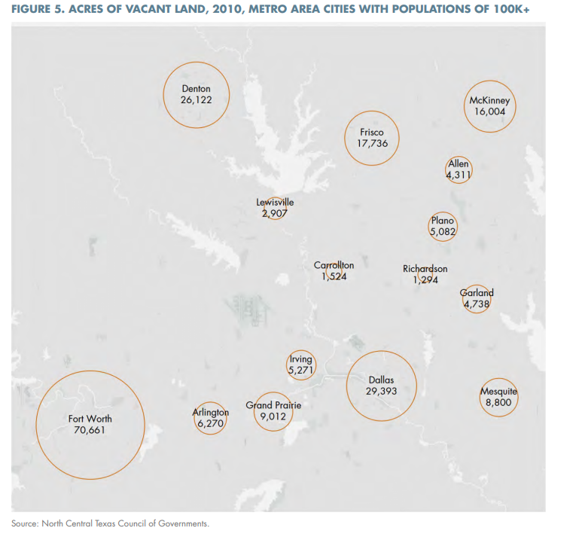
* *“When you combine these trends with the much higher level of employment growth in the Dallas side of the metro area—especially high-wage professional jobs—Fort Worth appears to be on its way to becoming a suburb of Dallas County. The fiscal challenges of growth driven by single-family residential development are illustrated below. A healthy tax base for a large central city must rely on high levels of business investment and employment growth. A center-city tax base dominated by residential uses is not sustainable for Fort Worth.”*
* 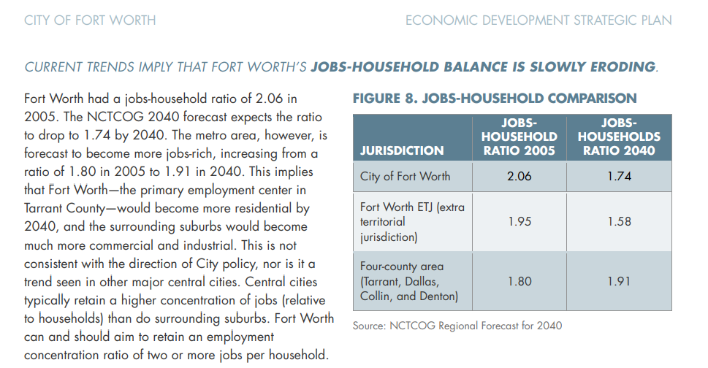
* *“Each of the three major groupings of districts described in the previous page—mature, established/emerging, and long-term plays—includes at least one district located within Fort Worth’s urban core. Downtown Fort Worth is the largest single employment center in Tarrant County. The Near Southside medical district is the largest single healthcare employment cluster in all North Texas.”*
* *“Fort Worth and Dallas are the owners of DFW International Airport. DFW is the 4th busiest airport in the US in terms of total passenger traffic. It has more than 200 nonstop destinations, including over 50 international airports. Among the 10 busiest US airports, DFW’s level of international passenger traffic is growing at the highest rate (53 percent growth of monthly international passengers from 2010 to 2016). Given the airport’s global reach and its recent growth trajectory—and the fact that “Fort Worth” is two-thirds of the airport’s name—DFW International Airport is clearly one of Fort Worth’s strongest assets.”*
* 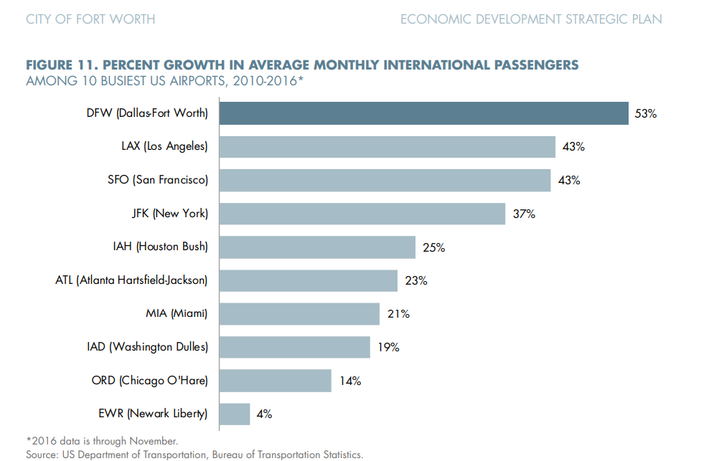
* *“Fort Worth’s hotel market is under-developed relative to neighboring Tarrant County cities and Dallas. The city of Dallas accounts for 46 percent of hotel revenues in the Dallas MD compared with Fort Worth, which accounts for 36 percent of hotel revenues in the Fort Worth MD. These statistics point to an unmet need and opportunity for additional hotel development, especially large hotels in downtown Fort Worth. The community would benefit from further analysis of the CBD and citywide hotel market to provide a better understanding of the opportunity. (See recommendations in Volume 3.)”*

### 2024-11-05

#### Daily Summary

The city has strong infrastructure and population + job growth, but lags behind Dallas for office development and high-wage office jobs.

The aviation sector has continued to be a large source of employment in the city, which makes sense given its history with aviation and the military.

#### Notes

* *“Seven Class I railroads serve the United States. Three of these—Union Pacific, BNSF, and KCS—are active in Texas, and all three serve the Dallas-Fort Worth metropolitan area (Figure 24). The tracks of Omaha-based Union Pacific and locally based BNSF crisscross the city of Fort Worth, with a critical intersection at the Tower 55 rail yard on the south side of downtown.   
    
  The intermodal connections of Class I railroads represent a much-desired infrastructure that is in limited supply nationwide. By this measure, the city of Fort Worth has a competitive advantage that other cities sometimes lack and cannot replicate. Union Pacific enters the city from six directions and BNSF from three. The Tower 55 rail yard in Fort Worth is considered by many to be one of the most important rail junctures in North America.”*
* *“Only 4 of the city's 10 largest employers in 2016 (Figure 25) were profit-seeking, private-sector entities (AMR, Lockheed, Alcon, and Bell Helicopter). The remaining six employers were governmental entities (Fort Worth ISD, NAS Joint Reserve Base Fort Worth, City of Fort Worth, and Tarrant County College) or as nonprofit health networks (JPS and Cook Children's). Together, these 10 employers provided the city with nearly 96,000 jobs in 2016.   
    
  Four of the city's largest employers cut heavily across the aviation sector in one way or another. In addition to two aircraft manufacturers (Lockheed Martin and Bell Helicopter Textron), the city's top employer is American Airlines, and its fifth largest employer is the local air base NAS Joint Reserve Base Fort Worth. These 4 employers provide aviation-related employment to nearly 54,000 workers in Fort Worth.”*
* *“The Dallas-Fort Worth metropolitan area has experienced consistently strong population and economic growth in the post-WWII decades, a dynamic that has propelled it into a major intercontinental hub of trade and traffic.”*

### 2024-11-06

#### Daily Summary

Manufacturing and logistics as well as aviation and aerospace are lead employers. These industries tend to employ older residents, and the consultants advise COFW to focus efforts on replenishing these talent pools.

Abundance of developable land means a good runway for growth. There is also a positive outlook in terms of revenue generation by the city.

COFW projected to fall below 2 jobs/household, and a large part of the pop is made up of “Barrios Urbanos” and other made-up segments which are low income.  
  
City is not developing as much office space as other Counties, and does not have an ecosystem that can retain technical talent or support startups well.

#### Notes

* 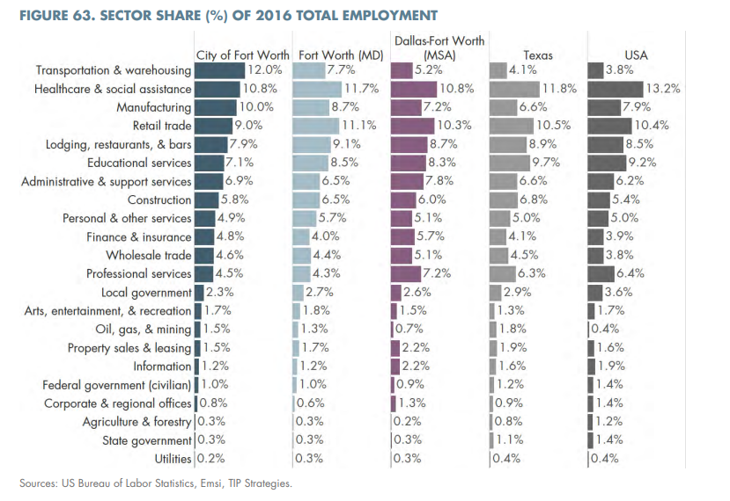
* 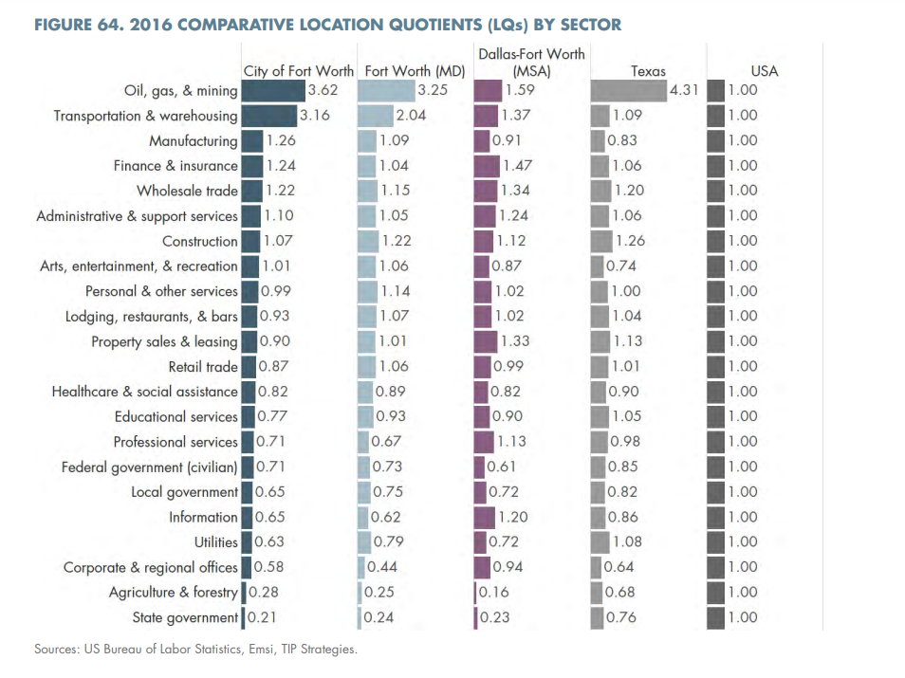
* 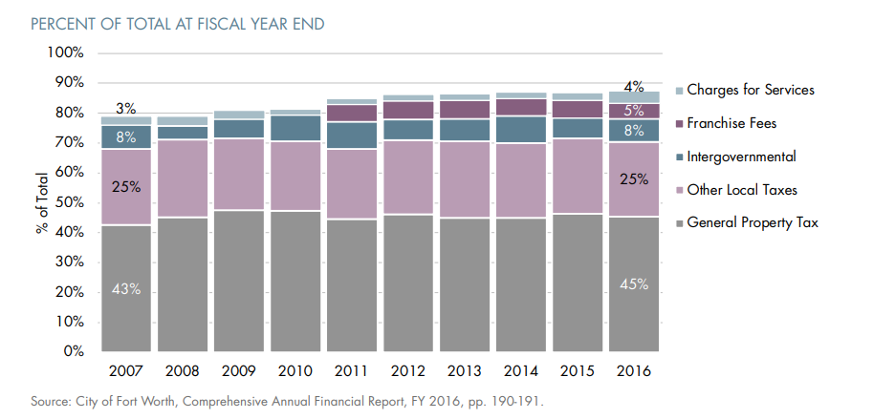
* 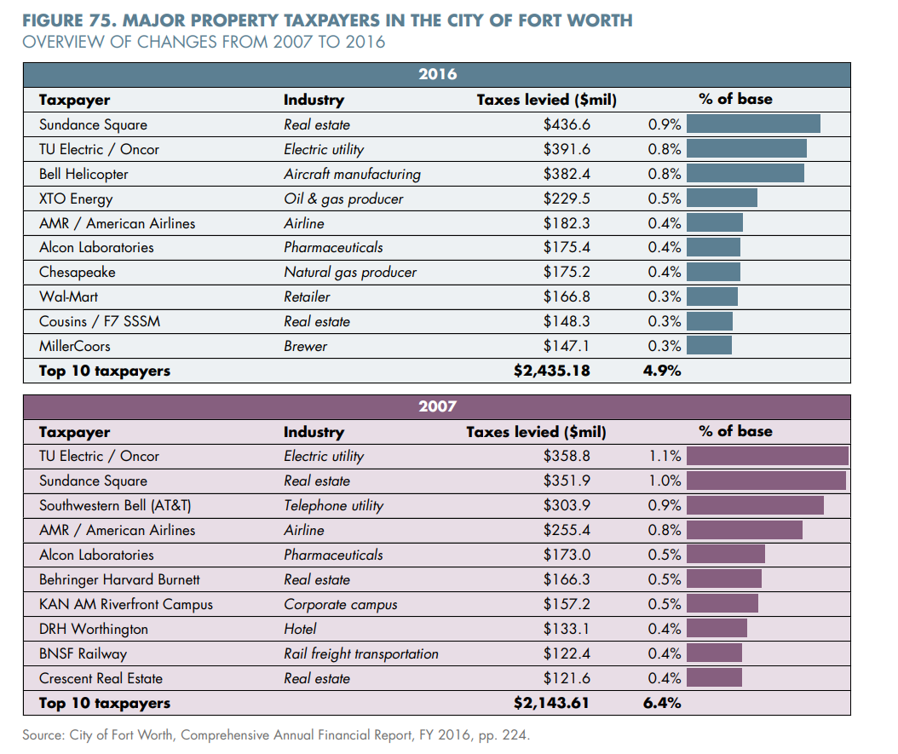
* *“Between 2010 and 2016, Fort Worth added nearly 13,000 single-family homes, more than any other city in the metro area. The net change in single family units in the city of Dallas was slightly negative over the same period.”*
* *“Using the general rule-of-thumb of 200 square feet of leased space per office worker, the Far North Dallas submarket is adding enough capacity to support more than 32,000 new office jobs, compared to new capacity underway in all of Fort Worth’s combined submarkets, which would support fewer than 2,000 new office workers.”*
* 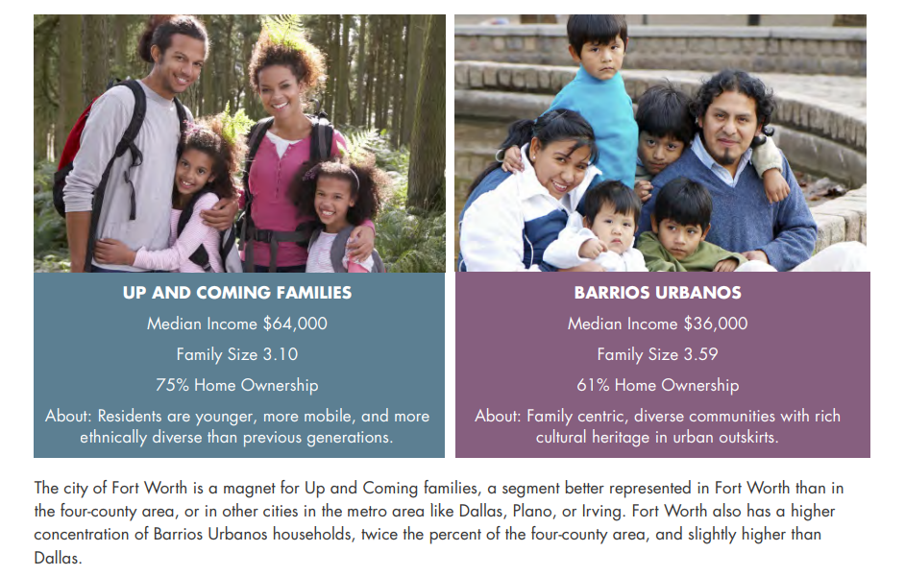
* 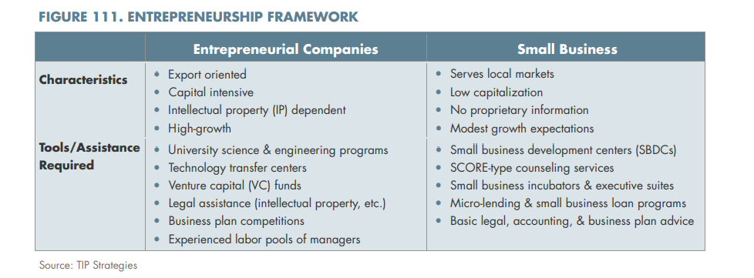

### 2024-11-07

#### Daily Summary

Fort Worth is higher than comparable metros in its warehousing and logistics sector. This was partially attributed to its abundance of land. In other areas, land constraints would usually push these uses outside city limits, and into suburban areas.  
  
The labor force has seen strong growth trends, but has been largely absorbed outside of the City, with the ever-important housing to jobs ratio projected to dip below 2.0 by 2040.  
  
This can lead to city residents consuming public resources (transportation, etc.) but contributing less than their potential, as the taxes related to their employment are absorbed elsewhere (I presume)  
  
It would be sort of like Fort Worth absorbing all the cost of infrastructure for a workforce, which is having a large chunk of potential tax rev siphoned off by neighboring metros like Dallas. (Again, from my understanding of their concerns in this report.)  
  
There is strong rent demand in the city, as illustrated by its low vacancy rate, and higher rent per square foot, as compared to the suburbs.  
  
Even with jobs in high wage professional services projected to increase, the city will need to encourage developers to invest in creating office space in order to absorb these new jobs, otherwise they will go outside the city.  
  
They can be incentivized to do so with the argument that demand for lawyers, accountants, etc. for existing businesses is strong in the metro, and these supporting professional services can be performed just as easily from Fort Worth as elsewhere.

There is an implied threat to the retention of existing large employers, as manufacturers in aerospace and aviation are facing an aging workforce, and a future where they will need more and more technically skilled employees, relative to current assembly line folks.  
  
There is an emphasis here on retraining and creating a pipeline in anticipation of these future needs, presumably to secure the continued existence of these employers within the city.

#### Notes

* *“Venture capital (VC) funding is the feedstock for high-growth companies and entrepreneurs. Nationally, VC funding is highly concentrated in a small group of technology-driven metro areas. The combined San Francisco/San Jose area accounts for more than $30 billion of VC investment in 2016, out of a roughly $70 billion US total. Add in the New York, Boston, and Los Angeles markets and this group of metro areas accounts for nearly $50 billion of VC deal value, about 70 percent of all VC investment. The DFW area captured $678 million in VC investment in 2016, less than 1 percent of the US total, compared with $977 million in Austin, the top Texas VC market. The Dallas-Fort Worth metro area lags other major metros in access to risk capital for entrepreneurs. Fort Worth—and its latent “old money” wealth—could play a role in filling this gap to provide more funding sources for area entrepreneurs.”*
* *“In Fort Worth’s case, the city encompasses a vast supply of land, much of it still undeveloped, which has made it possible to support low density, land-using employment sectors (like transportation & warehousing) that might have gone to suburban or exurban fringes of the urbanized area in any other metropolitan area.”*
* 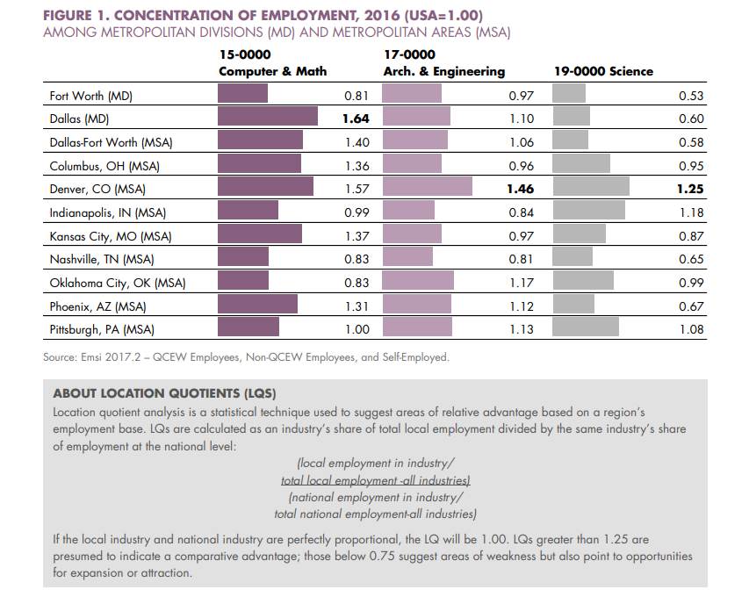
* Continued emphasis on the lack of STEM and comp-sci talent
* *“The transportation & warehousing sector is a significant source of employment and one of the city’s fastest growing. In 2016, one in every eight jobs in the city was in the transportation & warehousing sector. Between 2010 and 2016, the sector was second only to healthcare in terms of employment growth. The dominance of the transportation & warehousing sector—which includes the transport of passengers and freight using a variety of modes (e.g., truck, transit, rail, air)—reflects Fort Worth’s history as a crossroads. The city’s transportation assets include a network of interstate highways (I-20, I-30, and I-35), access to two Class I railroads (BNSF and UP), and two airports providing global connectivity (Alliance and DFW International Airport).  
    
  Fort Worth’s strengths in this sector are also reflected in its occupational structure, with nearly 11 percent of the city’s employment base in material moving jobs. This figure is significantly above the share that would be expected for a labor force of the same size based on national patterns, as evidenced by Fort Worth’s location quotient (LQ) of 1.61 for the occupational group. The city’s long history as a transportation hub, its dense network of transportation infrastructure, and human capital assets create a solid foundation for capitalizing on recent innovations in the industry, as outlined in the Emerging Opportunities section.”*
* *“Since 2010, manufacturing employment growth in the Dallas-Fort Worth metro area has taken place almost exclusively in the Fort Worth MD. Both the city and the Fort Worth MD have strong concentrations of employment in the sector relative to the national average, with LQs of 1.26 and 1.09 respectively. The manufacturing industries in the MD with the largest employment are aircraft, automotive, and pharmaceuticals. In Fort Worth, the employment in these industries is driven by Lockheed Martin and Bell Helicopter (for aircraft manufacturing) and Novartis’s Alcon subsidiary (for pharmaceuticals). General Motors is the primary driver of the MD’s automotive manufacturing employment in Arlington.”*
* *“Like the transportation & warehousing sector, the city’s manufacturing strengths are reflected in its occupational structure, with production workers accounting for just over 7 percent of the city’s total job base. This sector’s LQ of 1.22, indicates employment levels above national averages. However, as the sector becomes increasingly dependent on the development and adoption of new technologies, the ability to attract and retain a pipeline of skilled talent will become the major determinant in the health of the region’s manufacturing base. Fort Worth’s relative lack of workers in STEM-related occupations threatens to inhibit growth in this sector in the future.”*
* *“Fort Worth is one of the leading aerospace manufacturing centers in North America, a position that has become even stronger over the past quarter-century as Los Angeles’s strength has eroded due to industry consolidation and the migration of headquarters to be closer to the Pentagon. Numerous aerospace manufacturers operate in the Dallas-Fort Worth metro area, but the lion’s share of employment resides in Fort Worth. Between Lockheed Martin Aeronautics’ facility located at NAS Joint Reserve Base Fort Worth (where the F-35 and F-16 are manufactured) and Bell Helicopter Textron, there are nearly 20,000 workers in Fort Worth. Other companies, like Elbit Systems of America, play an important role in this sector as well. The industry’s extensive local presence means that Fort Worth has a specialized labor pool of skilled aerospace talent, an unusual asset in the US. The LQs within the Fort Worth MD are particularly noteworthy in several aerospace and aviation occupations: aerospace engineering & operations technicians (3.07), aerospace engineers (3.06), and mechanical engineering technicians (1.84).”*
* *“Technological innovations in the aerospace industry are affecting the occupations and skills required by employers, especially original equipment manufacturers (OEM) such as Lockheed Martin and Bell Helicopter. The traditional emphasis on “drill and fill” assembly workers dominating the production floor is shifting. New technologies and products like fly-by-wire flight controls and unmanned systems are increasing the demand for IT specialists (e.g., software developers and computer engineers). Likewise, the growing use of composites and utilization of additive manufacturing (3D printing) and robotics is also driving demand for production workers with advanced technical skillsets. Other occupations and positions projected to grow in the coming years include logistics and supply chain management positions and repair and maintenance technicians (especially for composite materials).”*
* *“These trends in the aerospace industry affect several of Fort Worth’s largest employers. Working with these employers to address their specialized skill requirements, amid a rapidly changing technological environment, should be a priority for the City. Meeting the growing demand for aerospace workers with advanced skillsets will require a greater emphasis on STEM education and training at the local level. A ready-to-go replacement workforce of younger, more diverse workers with modern technological skills will benefit Fort Worth from an employer retention standpoint, and it will also empower the workforce with skills adaptable to the more entrepreneurial climate that is evolving within this sector.”*
* *“The competitiveness assessment (the first volume of this 3-volume strategic planning process) identified several untapped opportunities in Fort Worth. Three of the key findings are worth reiterating. First, residential development and population growth in Fort Worth has been robust, but employment growth in the city has lagged the rest of the Dallas-Fort Worth metro area—especially in high-wage professional jobs. Second, many recent high-profile corporate relocation projects in the metro area have landed outside Fort Worth’s city limits (e.g., Toyota in Plano and Charles Schwab in Westlake). And third, the influx of tech firms and IT workers has also largely bypassed Fort Worth in favor of scattered locations in Dallas, Richardson, Plano, and Irving.   
    
  Fort Worth must take advantage of the metro area’s established position as one of America’s leading corporate HQ destinations. The city can ensure that it captures its fair share of corporate and regional HQ relocation projects by better marketing its advantages. For starters, Fort Worth is a city―not a suburb―in an era when cities are becoming more desirable corporate locations than suburban office parks. Established urban districts within Fort Worth provide the precise amenities most desired by corporate office tenants. Further, Fort Worth offers faster access to both DFW International Airport and Alliance Airport. Fort Worth essentially shares a metropolitan labor pool with its metro area competitors, offering equal access to the same large, rapidly expanding workforce that corporate employers are seeking. TCU Neeley Business School’s nationally ranked entrepreneurship undergraduate program sweetens the deal even more with its stream of creative young graduates.”*
* *“The Dallas-Fort Worth metro area’s professional service sector is projected to add nearly 42,000 jobs over the next five years. If the recent post-recession trends persist, where will those jobs go? Without an adequate supply of office space (especially newer, Class A buildings) to support them, the answer will not be Fort Worth. Using the rule-of-thumb of 200 square feet per worker, the five-year job projection translates to about 8.4 million square feet of office space absorption by the professional services sector alone, excluding all other types of office-using industries. Where within the metro area this speculative office space is built will be an important determinant of where the job growth can feasibly be absorbed.”*
* *“Fort Worth can begin to make a viable case for new office space by showcasing, for developers, the city’s potential internal demand drivers including its major employers who rely on the professional services of lawyers, accountants, engineers, consultants, etc., who could just as easily be located on the western side of the metropolitan area, namely Fort Worth. Startup activity is another demand argument, especially when considering the potential that the TCU Neeley Business School’s nationally ranked entrepreneurship undergraduate program could feasibly generate.”*
* *“These issues are echoed in the forthcoming North Texas Aerospace and Aviation Talent Pipeline Study. Per the (unpublished) study, regional aerospace employers are concerned about a coming wave of retirements, especially among workers in key occupations. To fill many of the critical positions, employers must do a better job of attracting women and other under-represented populations.   
    
  Air transportation companies in the Dallas-Fort Worth metro area are also facing talent pipeline challenges. Similar to aerospace manufacturers, air transportation employers report difficulty in identifying and attracting IT specialists and software developers. In addition, there is a concern about meeting the future demand for pilot positions. Airlines report a significant portion of their pilots are approaching the mandatory retirement age of 65. American Airlines is also in the process of transitioning newer aircraft into its fleet, which will require hiring additional commercial pilots with training and experience in operating the new aircraft.  
    
  In order to meet the talent pipeline needs of regional aerospace and air transportation employers, the North Texas Aerospace and Aviation Talent Pipeline Study recommends the development of a demand-driven career pathways system to connect residents to jobs in the aerospace and aviation industries. This is especially true for building a long-term supply (within the existing K-12 population) to meet many of the critical skills needs, especially in advanced manufacturing, information technology, and systems engineering.”*

### 2024-11-08

#### Daily Summary

The consultants used education as a proxy for skill-level when quantifying the workforce. The city, by their own estimates, is dominant in low and middle skills jobs. Jobs requiring anywhere from less than a high school degree to some brief training program (like registered nurses, or welders for example).  
  
The majority of jobs posted in the area over a 6-month time period were for nurses and truck drivers, reflecting a long-term shortage in these occupations nationwide.   
  
Most college degrees were in healthcare or business admin in the area.  
  
On a net basis, inflows from other areas and outflows to other areas of residents for work seems to be a wash. The largest net outflow (Fort Worth residents commuting elsewhere for work) is to Dallas.

Of personal interest to me, is the newer issue of remote work and its implications on taxes and corporate locations, as well as the fact that for fields like IT, education is not an appropriate proxy for skill level.

Companies and Governments seem insistent on quantifying and measuring the most human and nuanced qualities we have, and cling desperately to any sense of predictability.

We want corporate HQs and college graduates in our city limits because they “guarantee” certain numbers of projected tax revenue etc.

It is continuously disheartening to see our entire lives reduced to economic projections, but such is life.

#### Notes

* *“Educational attainment refers to the highest level of education completed for the adult population 25 years of age or older. This statistic is an indicator of workforce skills. Often the percent of the population with a bachelor’s degree or higher is used as a proxy for the general education level of a population and the availability of highly skilled workers. In the US, roughly 3 out of 10 adult residents (30.6 percent) have a bachelor’s degree or higher.”*
* 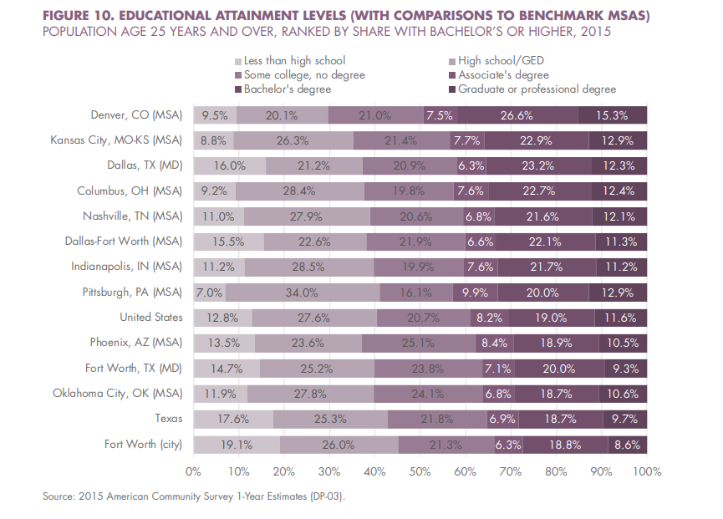
* 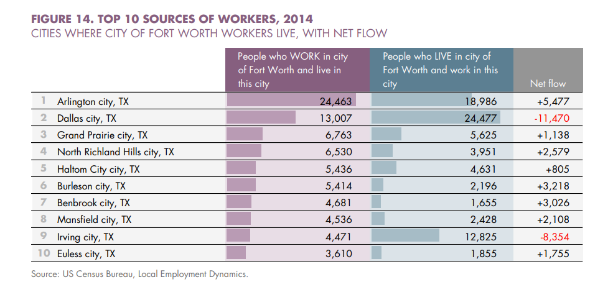
* 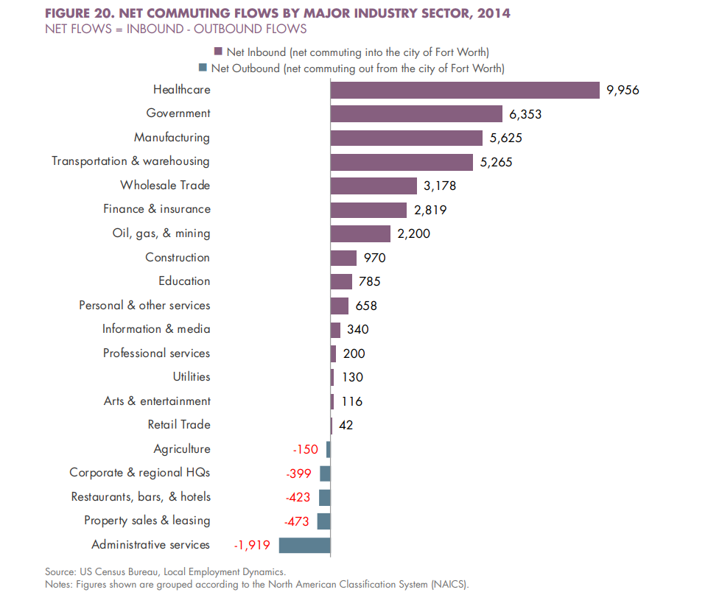
* *“Federal data on typical education, experience, and training requirements by occupation was used to segment the region’s employment base by skill level. Low-skilled occupations are defined as those requiring a high school diploma or less, while occupations requiring a bachelor’s degree or above are categorized as high skill. The remaining jobs (those typically requiring more than high school, but less than a four-year degree), are deemed middle-skills jobs. This broad category encompasses a variety of jobs that are essential to a wide range of industries. They include skilled trades, such as plumbers and electricians, as well as production workers, healthcare technicians, and administrative support functions. By this measure, Fort Worth has seen above-average growth in middle-skills positions, but lags the region, state, and nation in high skills employment growth.”*
* *“Some of the difference is accounted for by Fort Worth’s slightly larger share of middle-skills jobs, a category that has garnered significant attention as a pathway to living-wage employment. However, Fort Worth has a relatively large share of its employment base in low skilled positions. At 45 percent of the total employment base, this figure was the highest among the metropolitan areas analyzed. Furthermore, as shown in the prior figure, low-skill employment has historically grown at a higher rate in the Fort Worth MD than in the Dallas-Fort Worth MSA and this trend is projected to continue going forward.”*
* *“Median wage rates in the Fort Worth MD are largely in alignment with national rates. Again, the area’s strengths in transportation-related positions can be seen, as median wage rates for this occupational group exceeds the national median. Groups that fall below the national rate include legal occupations and construction and extraction workers.”*
* 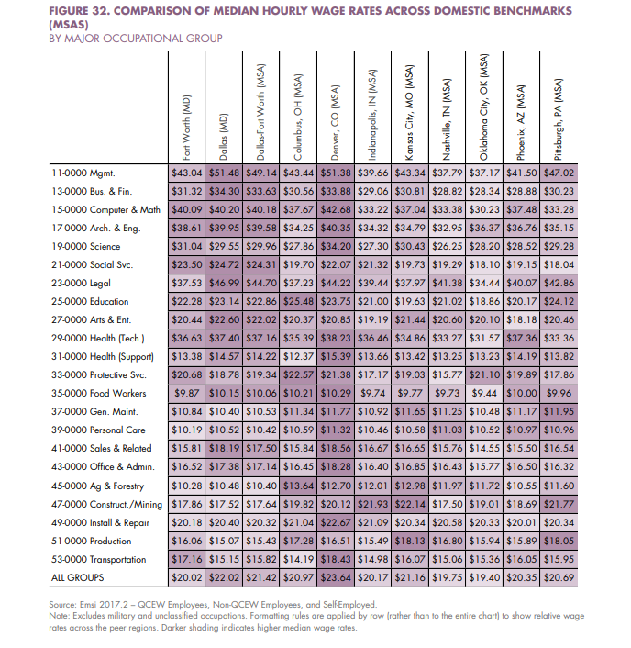

### 2024-11-11

#### Daily Summary

Lots of charts in pages 250-300.   
  
Airlines have 1/3 of jobs in transportation and logistics sector, but growing slowly.  
Employers mostly complained about their inability to outsource training to the city.

#### Notes

* *“In addition to being the most commonly expected area for hiring, professional positions are also among the hardest to find, with roughly one in four respondents (26 percent) indicating that vacancies take four months or more to fill. By contrast, 85 percent of unskilled positions are filled in a matter of weeks.”*
* 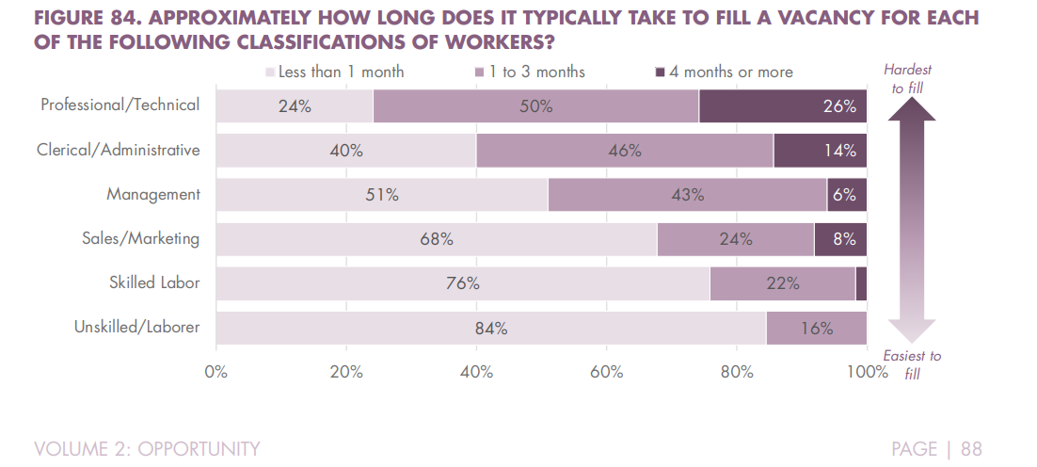
* *“Scheduled passenger air transportation is the largest source of employment in the Fort Worth MD’s transportation & warehousing sector (accounting for 30 percent of the sector’s 80,000 total jobs), but it only represented 6 percent of job growth in the sector from 2010 to 2016. Three other subsectors—general warehousing & storage, long-distance general freight trucking, and local general freight trucking—gained a total of 8,000 new jobs, representing more than 50 percent of total job growth in the sector.”*

### 2024-11-12

#### Daily Summary

Fort Worth has a low rank nationwide for **Healthcare** jobs, but shows high growth.  
  
There is a large potential for **Tourism** related growth in the area, due to our unique attractions like the stockyards, etc.  
  
**Aerospace Manufacturing** is a strength of the city, with a high concentration of jobs.   
  
Along with **Air Transpiration**, both industries are struggling with an aging workforce and the need for a pipeline of more “high-skilled” (Highly educated, STEM focused) talent.  
  
Writers advocate that Fort Worth be marketed as a location for **International Business** due to its highly interconnected airport, and high existing immigrant population.  
  
There is also a note that **Financial Services** could be grown, using TPG (former Bass family people) as a magnet and marketing tool; this is pointed out in line with an opportunity to grow **Professional Services** (accountants, bookkeepers, architects, engineers, consultants) in the region.  
  
Writers point out that corporate relocations are more common for younger companies, and tend to create industry clusters in geographic areas.  
  
They also mentioned trends in transportation tech and fintech; and pontificated on potential opportunities to attract companies and talent either directly in the form of the firms in these sectors, or indirectly. The latter being in the even that certain functions (like cybersecurity) wind up being outsourced.

#### Notes

* *“The Dallas-Fort Worth metro area is not among the five largest healthcare markets in the US, despite being the fourth largest metro area ranked by total employment and population. With an LQ of 0.89, the metro lags the US economy in healthcare jobs. However, the metro area’s 24 percent growth rate of healthcare employment from 2010 to 2016 was the highest among large metros (tied with Atlanta), a strong sign of the region’s growth potential in this industry. Fort Worth, with its high concentration of medical institutions in the Near Southside, can (and should) play a leading role in further growing the region’s healthcare sector.”*
* *“Las Vegas and Orlando stand out as the most successful major metro areas with economies driven largely by tourism. Las Vegas has a larger tourism sector in absolute size (ranked by total employment) than even New York and Los Angeles, with an LQ of 8.72, nearly nine times higher than the US average. Orlando’s LQ of 5.46 also reflects a highly-concentrated tourism sector. Two metro areas that have seen major recent job growth in tourism, despite not historically being driven by the sector, are Austin and Grand Rapids, which respectively ranked second and third in the US in percentage growth of tourism jobs. Each of these communities has benefited substantially from the rise of internationally-recognized events: SXSW and F1 in Austin and ArtPrize in Grand Rapids. Not only does Fort Worth’s Main Street Arts Festival rank among the largest artist events in the US, the city also boasts a multitude of tourism assets (arguably more than either Austin or Grand Rapids), such as the Stockyards, Cultural District, Sundance Square, and the Texas Motor Speedway. Yet these assets have not been fully capitalized on for economic development. More emphasis should be placed on the potential for tourism to drive economic growth in Fort Worth.”*
* *“Fort Worth is one of the leading aerospace manufacturing centers in North America. The Dallas-Fort Worth metro area has numerous aerospace manufacturers, but the lion’s share of employment resides in Fort Worth. Between Lockheed Martin Aeronautics’ facility located at NAS Joint Reserve Base Fort Worth (where the F-35 and F-16 are manufactured) and Bell Helicopter Textron, there are nearly 20,000 workers in Fort Worth. Other companies, like Elbit Systems of America, play an important role in this sector as well.”*
* 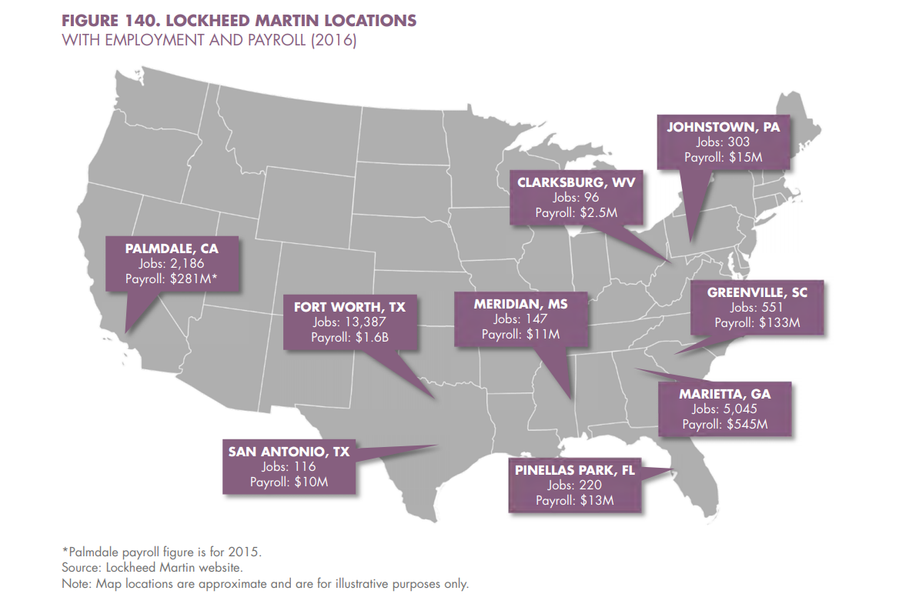
* *“The future is dimmer for defense contractors. Although passage of the Bipartisan Budget Act of 2015 extends relief from the full impacts of sequestration through 2017, uncertainty about the federal budget continues. However, PwC cites “rapidly changing US defense priorities” (including global threats from ISIS, the Russia-Ukraine conflict, and growing modernization of the militaries of North Korea and China) as a force that is likely to help drive compromise in future budget deals.”*
* *“Technological innovations in the aerospace industry are affecting the occupations and skills required by employers, especially original equipment manufacturers (OEM) such as Lockheed Martin and Bell Helicopter. The traditional emphasis on “drill and fill” assembly workers dominating the production floor is shifting. New technologies and products like fly-by-wire flight controls and unmanned systems are increasing the demand for IT specialists (e.g., software developers and computer engineers). Likewise, the growing use of composites and utilization of additive manufacturing (3D printing) and robotics is also driving demand for production workers with advanced technical skillsets. Other occupations and positions projected to grow in the coming years include logistics and supply chain management position and repair and maintenance technicians (especially for composite materials).”*
* *“To meet the growing demand for aerospace workers with advanced skillsets will require a greater emphasis on STEM education and training at the local level. At the same time demand for these workers is increasing, Fort Worth’s aerospace employers are facing the challenge of an aging workforce (see again Figure 122, page 111). According to the forthcoming North Texas Aerospace and Aviation Talent Pipeline Study, regional aerospace employers are concerned about a coming wave of retirements, especially among workers in key occupations. To fill many of the critical positions, employers must do a better job of attracting women and under-represented populations.”*
* *“The air transportation companies in the Dallas-Fort Worth metro area are also facing talent pipeline challenges. Like aerospace manufacturers, air transportation employers report difficulty in identifying and attracting IT specialists and software developers. In addition, there is a concern about meeting the future demand for pilot positions. Airlines report a significant portion of their pilots are approaching the mandatory retirement age of 65. American Airlines is also in the process of transitioning in newer aircraft into its fleet, which will require hiring additional commercial pilots with training and experience operating the new aircraft.”*
* *“In order to meet the talent pipeline needs of regional aerospace and air transportation employers, the (unpublished) North Texas Aerospace and Aviation Talent Pipeline Study recommends the development of a demand-driven career pathways system to connect residents to jobs in the aerospace and aviation industries. This is especially true for building a long-term supply (within existing K-12 population) to meet many of the critical skills needs, especially in advanced manufacturing, information technology, and systems engineering.”*
* *“Few cities have as many strategic advantages as Fort Worth for attracting investment in transportation innovation. The city’s economic roots can be traced to investments and new innovations in transportation, starting with stagecoaches and cattle drives, then transitioning to railroads and highways, and eventually air travel. Fort Worth’s infrastructure assets (e.g., DFW International Airport, Alliance Airport) and its business leadership (e.g., American Airlines, BNSF, Lockheed Martin, Bell Helicopter Textron, Epic Helicopters) position the city to become a test bed for the evaluation and deployment of new transportation solutions.”*
* 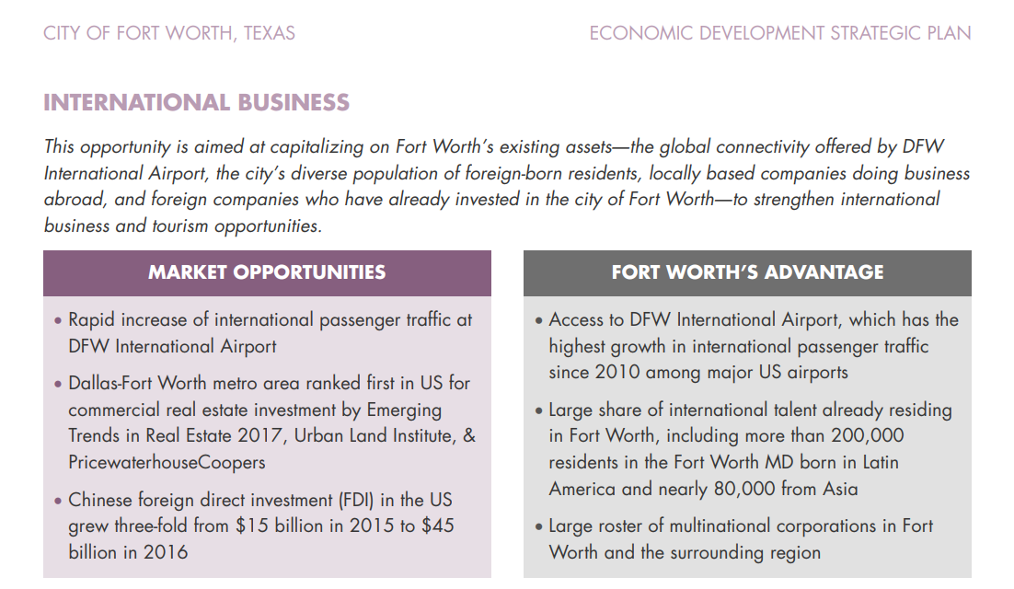
* *“The third pillar is a diversity of immigrants, a labor pool and cultural resource the city of Fort Worth and the surrounding North Texas area have welcomed. In 2007, after years of research, the scholar AnnaLee Saxenian published a landmark book called The New Argonauts: Regional Advantage in a Global Economy, in which she meticulously documented the role that immigrants had played in shaping the Silicon Valley economy through deep bilateral connections with places like Taiwan and India. Saxenian called this “brain circulation.” Saxenian’s book underscored the unique role that US-educated immigrants can play in developing global business relationships.”*
* *“While corporate HQs are classified under a single code in the NAICS system (55), corporate and regional HQ operations occur across all industry clusters. In essence, corporate HQs are not really an industry, but they are a legitimate target for business recruitment. The Dallas-Fort Worth metro area is one of the leading corporate centers in America with 22 Fortune 500 HQs and a total of 42 Fortune 1000 HQs. However, Fort Worth has not benefited from the region’s status as a corporate hub. The city only claims one Fortune 500 HQ (American Airlines) and one additional Fortune 1000 HQ (Pier 1 Imports). Recruitment of corporate and regional HQ operations into Fort Worth, especially into the urban core, must be a key focus area of the city’s economic development program.”*
* *“A final consideration when targeting corporate headquarters is the fact that these operations have a tendency to cluster by industry. Los Angeles, for example, has a strong cluster of media-related companies: the Boston– Washington corridor is rich with corporate offices for banking and insurance, especially New York, Philadelphia, Stamford, and Hartford; corporate offices related to energy, power, and raw materials are clustered in cities like Houston, Cleveland, Akron, and Pittsburgh. Matching specific corporate targets with regional clusters can help facilitate success. The most obvious corporate HQ targets for Fort Worth would fall within the city’s existing industry strengths in transportation, oil & gas, and manufacturing.”*
* *“It is also important to keep in mind that “economic clusters” may be as likely to evolve around technologies (like cybersecurity, for example) as they are around traditional industries (like financial services). For example, the media outlet Xconomy reported in April 2016 that more than 60 cybersecurity firms were operating within an hour’s drive of Boston’s financial district.2”*
* *“Fort Worth, too, counts itself in this elite group, thanks in large part to TPG Capital (formerly Texas Pacific Group), which consistently ranks as one of the world’s largest private equity firms. Being the hometown of a major global player in private equity carries two unique advantages from an economic development perspective. The first is regenerative potential. TPG itself was founded by financial managers with ties to the Bass family, and Fort Worth would be a logical home for any future spin-offs or breakaways from the talented group of Fort Worth managers TPG has assembled. This is how talent clusters grow. Along with TPG, the city is home to several other private equity firms, including Crescent Real Estate, Luther King Capital Management, and Crestline Investors, Inc”*

### 2024-11-13

#### Daily Summary

Consultants advocated for, and outlined specific marketing efforts. These included marketing to real estate brokers and other professionals through gift packages, marketing material, hosting and attending conferences etc. to drive real estate led growth in the city.  
  
There was also discussion of creating a fund by diverting some property tax and natural resource extraction revenue.  
  
Marketing to talent was also mentioned, along with an emphasis on public amenities (parks, trails, etc.), small local businesses (coffee shops, retail stores), and the arts as assets to attract talent to the city; along with DFW airport Wi-Fi marketing (via mandatory ads about the city to access the Wi-Fi) and monitoring of the city’s Wikipedia page.  
  
There was a fine point put on the need for redevelopment of residential space in Downtown to attract businesses, as well as in concentric circles emanating from downtown; and for development and redevelopment of high density residential and mixed use space to attract business to districts.  
  
Ended today’s reading around page 400, with a section outlining the need for full time staff for various initiatives. BRE, Research, and business attraction should all get full time staff, and there should be a close partnership between the City of Fort Worth’s economic development department, and the Chamber of Commerce.

#### Notes

* *“While public-sector investments such as transportation networks and water/wastewater systems are necessary to set the stage for economic development, the private sector is responsible for the vast majority of the built environment in US cities. This is especially true in the Dallas-Fort Worth metro area, where the real estate development and brokerage community drives a high level of business expansion and recruitment activity. Compared with Dallas and its northern suburbs, Fort Worth is an afterthought among regional and national real estate professionals. Current and recent construction of office space exacerbates this problem, with more than half of all ongoing class A office space under construction in a narrow corridor stretching from downtown Dallas, up through Plano, and into Frisco. In light of their importance to the process, building relationships with brokers and developers should be a major focus of the City’s marketing and recruitment efforts.”*
* *“Fort Worth has largely ignored one of the most promising business development opportunities: capturing international business development and foreign direct investment (FDI). The prospect of increased FDI in the US is a strong argument for Fort Worth establishing a strategy to capitalize on this opportunity. In recent years, the only major players in the Dallas-Fort Worth metro area that have invested significantly in recruiting international businesses are DFW International Airport and the Dallas Regional Chamber. As such, a large share of the region’s FDI projects have landed in the City of Dallas and North Dallas suburbs near the airport such as Plano and Irving.”*
* *“The City and Chamber must establish a set of filtering mechanisms to identify target companies as part of the BRE program. This should be structured around a tiered approach that prioritizes companies that are at risk of downsizing/relocating, have significant growth potential, and fall within the city’s target industries. Relationships must be cultivated not only with local business leaders, but also with executive leadership (e.g., CEOs, CFOs, global real estate directors) of Fort Worth’s major employers whose HQs are located elsewhere. Beyond the companies themselves, connections must also be made with relevant professional service providers that offer a different understanding of the company’s needs and challenges, such as accounting firms, legal firms, marketing/PR firms, and commercial real estate professionals. The program should coordinate BRE efforts among organizations to fully leverage available resources and relationships and to exchange vital information. Focus should be on the Chamber and City relationships (including the Mayor’s office), but should also extend to the local business relationships maintained by the Fort Worth Hispanic Chamber (FWHC) and the Fort Worth Metropolitan Black Chamber (FWMBC).”*
* *“Access to a skilled workforce consistently ranks at or near the top of the list of site selection factors ranked in Area Development’s Annual Survey of Corporate Executives. The Dallas-Fort Worth metro area consistently attracts new business expansion projects that create thousands of new jobs on a monthly basis. Some of these new jobs will be filled by workers moving into the area from outside of the region and state, but the majority will be filled by local talent. This places the burden on communities in the region to develop a pipeline of talent to support the area’s rapidly expanding economy.”*
* *“Fort Worth’s most prominent workforce and industry partnership is the regional DFW Aerospace Consortium. The community needs to increase its commitment to the consortium’s programs and promote a greater emphasis on design, R&D, and technology-related skills. Fort Worth should also play an active role in other regional workforce & industry partnerships, such as the North Texas Supply Chain Council and similar efforts focused on technology, healthcare, and infrastructure.”*
* *“A formal “medical innovation district” designation would start with additional public investments to enhance walkability and pedestrian connectivity, as well as support broadband that creates extended connectivity across all devices, both wired and wireless. It would also involve the creation of incentives for talent recruitment (e.g., a nationally recognized life sciences researcher) that would advance the district and attract additional research staff. Establishing the district formally will also provide opportunities to generate national attention about the district and to invite outside organizations to evaluate the area and uncover strategies for accelerating its development.”*
* *“Entrepreneurial companies have specific needs for talent, real estate, and capital. The undercurrent for all of these needs is the network of people involved in supporting the growth of entrepreneurial companies. Communities with a highly engaged, connected, and collaborative startup scene have a built-in advantage in the global competition for high-growth business development. Fort Worth has all of the building blocks needed to support a higher level of entrepreneurship: TECH Fort Worth and other strong support organizations, talented entrepreneurs and workers in the city and metro area, innovative companies and higher education institutions in the area, and a growing menu of real estate options suitable for tech firms and startups (including WeWork and other co-working spaces and an expanding supply of attractive office spaces in downtown and the Near Southside). What Fort Worth and the entire metro area lack is a robust networking environment for local entrepreneurs and tech workers. In fact, the only city in Texas that does this well is Austin.”*
* *“A stronger, more connected set of networking channels for entrepreneurs, investors, and tech workers in Fort Worth will help existing startups and tech firms. Just as important, this will help the city become a hub of entrepreneurial activity, positioning it to attract entrepreneurs and high-growth companies from across the metro area, state, and nation.”*
* *“The City should create a Futures Forum as an internal city leadership group that also seeks guidance from outside experts around specific topics. Other cities have created similar internal leadership groups. Fort Collins, Colorado, created its Futures Committee to assist City Council members in their decision-making process. They meet monthly with a goal “to position the City in the distant future (30 plus years) for achievable successes, integrating community desires with known fiscal, social, and environmental data.””*
* *“A more aggressive agenda for rapidly expanding the base of residents living in and around downtown Fort Worth will generate much more than new housing in the urban core. With thousands of new residents moving into downtown, Panther Island, the Near Southside, and other close-in districts over the next several years, other target audiences will take note. A rapidly expanding urban population base is the key to unlocking the city’s potential for attracting new commercial office development, corporate HQs, professional services firms, and tech companies.”*
* *“Design marketing materials around Fort Worth’s target industries. For the life sciences delivery (and clinical trials) opportunity, create a one-pager promoting “The Fort Worth clinical environment” and attend 2-3 major conferences (e.g., Bio, JP Morgan Chase Healthcare Conference) to promote the city as a destination for clinical trials. Create other industry-specific marketing and promotional materials along the same lines.”*
* *“Actively manage other online sources with city information, such as Fort Worth’s Wikipedia page, to ensure they depict an accurate and positive image of the city as a business location. This is an important, but often overlooked, facet of economic development marketing since many prospective business executives and relocating workers use Wikipedia and other online sources as their starting point for researching a community before they make a visit in person. This is an ideal ongoing task for local college student interns working under the supervision of City and/or Chamber economic development professionals.”*
* *“1.3.2. Use Customer Relations Management (CRM) software between the City and the Chamber to better monitor business issues and concerns. 1.3.2.1. The City and Chamber should use a CRM to track all leads and prospects, including compliance of companies receiving incentives. 1.3.2.2. Explore shared use of technology tools and programs for managing BRE visits and other aspects of Fort Worth’s economic development program.”*
* *“Marketing initiatives designed to recruit businesses are most successful when they are customized for specific audiences. The same is true about marketing messages for the attraction of talent. The city would benefit from a highly-targeted talent recruitment program. This must include specific messages geared toward two distinct groups: 1) professionals already residing in the Dallas-Fort Worth metro area; and 2) skilled workers moving into the region from outside of Texas. In the eyes of both groups, Fort Worth needs to become a top-choice destination for the upper echelon of talent.”*
* *“1.4.2.4. Take the FIND IT. FORT WORTH. initiative on the road to provide opportunities for employers to conduct joint marketing efforts aimed at specific pools of talent. Travel to SXSW (and other major events where key segments of talent congregate) to promote local employers. Visit major metro areas with a high concentration of workers in Fort Worth’s in-demand occupations to market the area as a top relocation destination. Focus on markets where a recent layoff, corporate merger, or other event has occurred that freed up workers in those competing cities. Focus on recruiting occupations that serve numerous industries in the local economy. Software/IT talent is one example of an underlying support structure for the growth of practically all industries in Fort Worth (manufacturing, transportation, healthcare, oil & gas). Target specific hard-to-recruit occupations in demand from local employers, such as aerospace engineers, computer systems analysts, software developers, and other critical STEM (science, technology, engineering, and math) occupations.”*
* *“DOWNTOWN + ALLIANCE PARTNERSHIP: Fort Worth has something no other city in the metro area can claim: a vibrant downtown district and a dynamic suburban growth center. Downtown Fort Worth and Alliance play distinct economic roles and offer distinct advantages for doing business. Downtown offers prime office space, urban residential options, nightlife, a high concentration of hotels, and a walkable environment connecting these uses and amenities. Alliance is the perfect location for land-intensive operations requiring transportation access (highway, rail, and air) as well as high-speed broadband internet within a secure corporate environment. Downtown and Alliance rarely compete. In fact, their distinct value propositions represent mutual benefits. A large distribution or data center would not consider locating downtown. Likewise, a corporate headquarters in a downtown office tower is unlikely to locate in a far-away greenfield site. Fort Worth’s advantage lies in the large number of companies in both locations that could expand. Downtown-based firms could open facilities (e.g., a data center) in Alliance. And companies operating in Alliance could open offices (e.g., a software development center) in downtown.”*
* *“3.3.4. Showcase the success of La Gran Plaza, an under-appreciated minority-business success story and qualityof-life asset in Fort Worth. 3.3.4.1. Use this as a model for other development projects in under-served neighborhoods in the city. Cultivate relationships with minority-focused real estate developers and investors with a track record of creating projects that provide retail and services to under-served populations in urban markets.”*
* 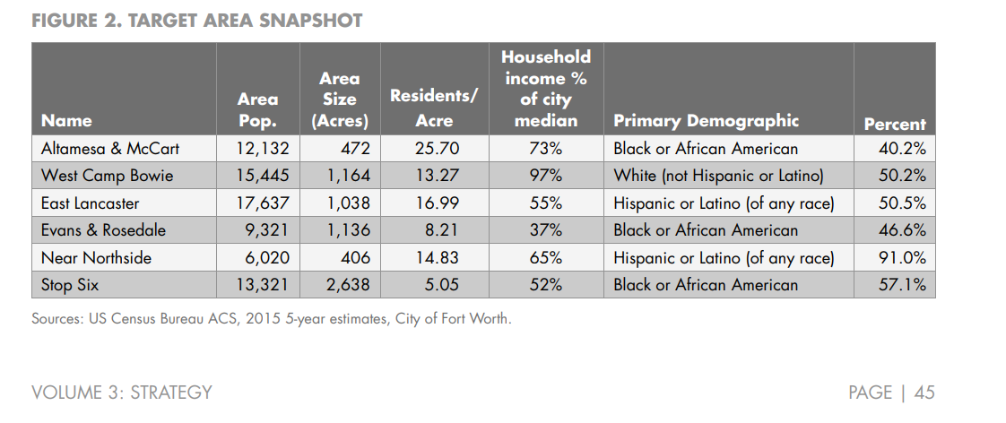
* *“New investments from the City and the Chamber will be required to move this plan from concept to action. The success of models like Opportunity Austin is well documented. Under this approach, the Greater Austin Chamber of Commerce is responsible for marketing and recruitment, while the City of Austin focuses on incentives. The City provides funds for the Chamber, which are tied to clearly defined performance metrics. Fort Worth’s economic program should move toward this model, but with even stronger collaboration between the City and the Chamber.”*
* *“While communication between the City and the Chamber has been very good, the significant increase in the marketing capacity of the Chamber requires a more formal collaboration. The Chamber should commit to sharing economic development prospects likely to require City participation in the form of incentives, infrastructure, development review processes, or other City-led assistance.”*
* *“In a sense, the City/Chamber partnership is no different than a private sector business development model, in which a sales funnel converts a suspect into a prospect, and a prospect into a customer. In the private sector model, sales teams communicate internally with other staff during the sales process to ensure that external communications (messages delivered to the prospect) accurately reflect the company’s qualifications and commitments. Adopting a similar approach to the “reactive” side of Fort Worth’s economic development program, responding to prospects, will be the most effective approach for ensuring a strong partnership between the City and the Chamber. We recommend that a formal meeting be held every two weeks during which the Chamber reviews prospects with the City. This review should consider timeframes, necessary staffing, and expected involvement required of the City.”*
* *“Fort Worth’s economic development program needs a strong research team to support the various initiatives outlined in the plan. At a minimum, three staff positions will be needed for this function, with two housed in the Chamber and one housed in the City. The Chamber research team should focus on developing a robust knowledge base of local industries, employers, and talent, along with competitive information on target industries nationally and within competitor metro areas. The City research team should focus on maintaining a deep understanding of all aspects of the local and regional real estate market (commercial office, industrial, retail, hotels, and residential), redevelopment projects, incentive programs (utilization and performance), and the local tax base (commercial property tax, sales tax, and hotel revenues). The two research teams should function almost as a single unit, with strong crossover between areas of expertise and focus areas. In other words, City and Chamber research teams should have their own distinct areas of focus, but should be completely conversant and knowledgeable in all research areas. The research team must include strong GIS capabilities.”*

### 2024-11-14

#### Daily Summary

Metrics are defined and provided for measuring success in key areas for the city, along with relevant data sources. These could be an interesting starting point for a future phase of this project, or my “City Scorecard” project in the future.  
  
Marketing between orgs in the city is deemed unoriginal, and inconsistent, relying on cliches and not clear on roles and responsibilities.  
  
It seems that Fort Worth lags other cities in the area in terms of investment in economic development (infrastructure, and other public improvements), and in its incentive offerings to businesses, which have led to relocations landing in other cities within the metro area.  
  
In stakeholder survey attachments, crime rates, a poor education system, and the **development process** were all cited as deterrents for site selectors bringing projects to the City.  
  
The data I analyzed could be used here to see number of permits per year, permit use types, and average time to permit for those (development permits?) that are finaled. (Time for all sub-permits to be granted.)

#### Notes

* 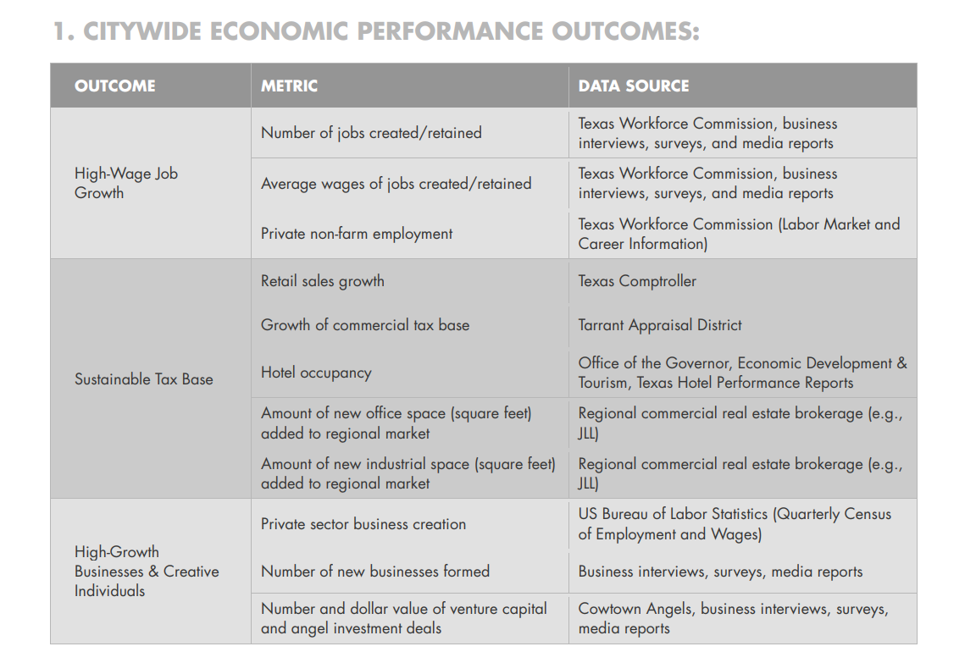
* 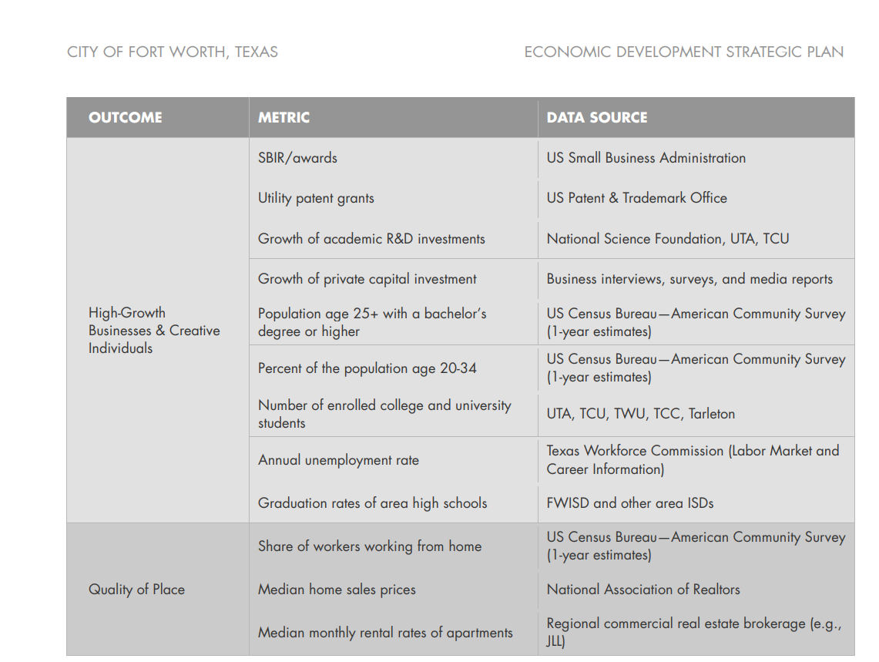
* 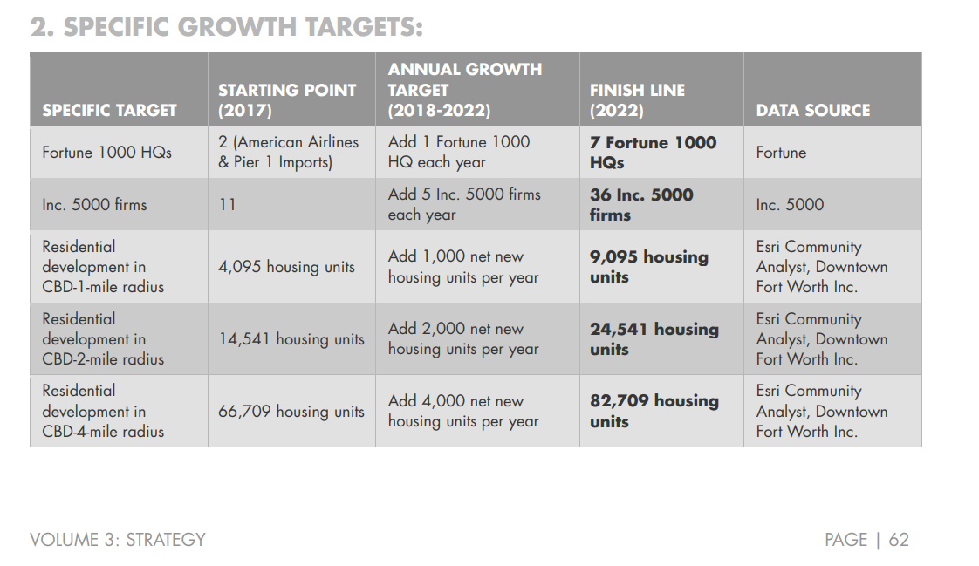
* *“Fort Worth currently competes for the same prospects that are choosing to locate in Dallas, Plano, Frisco, Irving, Allen, and McKinney. While most of these prospects could locate in Fort Worth, too many ultimately decide against making an investment in the city. In some cases, a perceived weakness is the deciding factor; perceptions of the quality of Fort Worth ISD and a lack of an effective transportation system were referenced in both the stakeholder survey presented in Volumes 1 and 2 and in the broker perception survey presented in Attachment A. Addressing these perceived weaknesses will be essential to the city’s future economic vitality.”*
* *“However, the planning process suggests the lack of a proactive economic development response is an equally significant factor affecting the City’s ability to capture its share of the region’s growth. The Dallas-Fort Worth metro area is a highly competitive region. Dallas has a strong City economic development department and the Dallas Regional Chamber is very aggressive. There is no counterpart to this partnership in Fort Worth. The City is also faced with competition from dozens of Dallas-Fort Worth metro area sales tax corporations. In particular, the Type A economic development corporations in Frisco, Allen, and McKinney are extremely effective.”*
* *“The organizational review presented in Attachment D illustrates that the City of Fort Worth has among the lowest staffing levels of economic development personnel compared with the US benchmark cities. The analysis also reveals that funding and staff resources for economic development in Fort Worth falls short of most competitor cities in the Dallas-Fort Worth market, in terms of both operations and incentives. Accordingly, the City should start by streamlining and enhancing the necessary “reactive” part of economic development: responding to prospects. This step should be followed by significant new investments in the “proactive” side of economic development: generating leads and cultivating relationships that lead to new business development opportunities.”*
* *“In addition to being better resourced, many of Fort Worth’s metro area competitor communities have more robust incentive offerings. For example, Plano’s property tax-funded economic development incentive program has been very effective. The program is credited with playing a key role in luring Toyota and JP Morgan Chase into the community, which together are expected to result in 10,000 new jobs.”*
* *“An important focus of the City’s economic development strategy must be increasing Fort Worth’s competitiveness within the region by introducing new and expanded incentive programs. Consideration should be given to providing incentives for companies that lease office space. This strategy would help the community attract more professional service companies (including tech firms) that would not otherwise qualify for existing tax abatement incentives, because their expansion does not include significant capital investment.”*
* *“…And other aspects of the survey suggest that Fort Worth’s development process is viewed unfavorably. Within the Dallas-Fort Worth market, Fort Worth is among the least competitive locations of those rated in terms of key local factors such as K-12 school performance, labor access, and commercial office space availability. Fort Worth also received relatively low marks on the presence of research universities, however, this factor was viewed as the least important among those analyzed.”*
* *ATTACHMENT A. PERCEPTION SURVEY*
  + 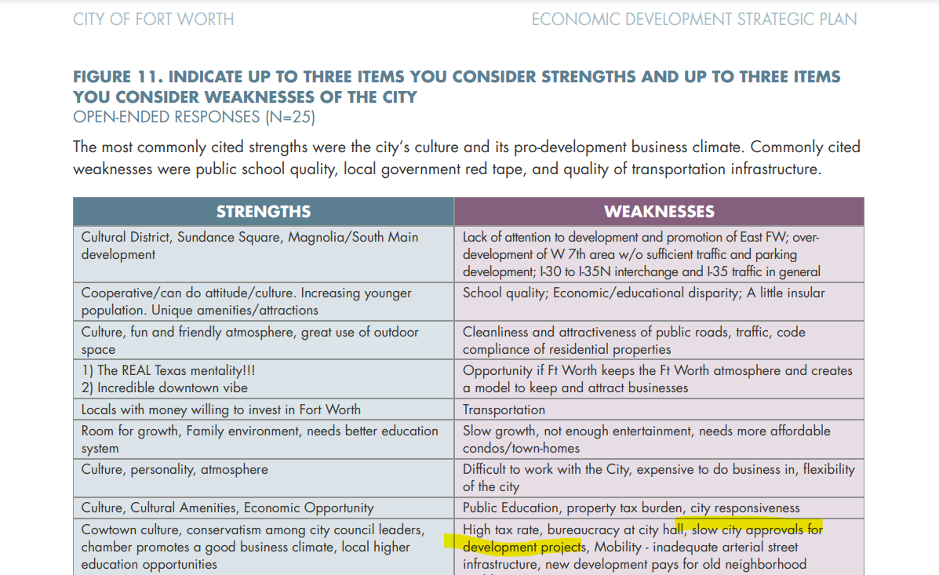
  + 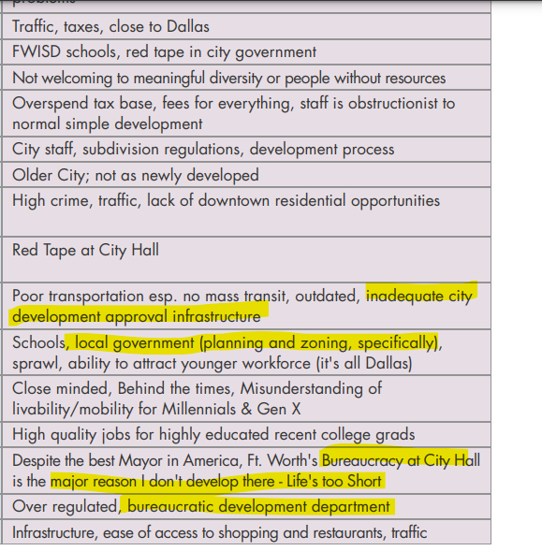
  + 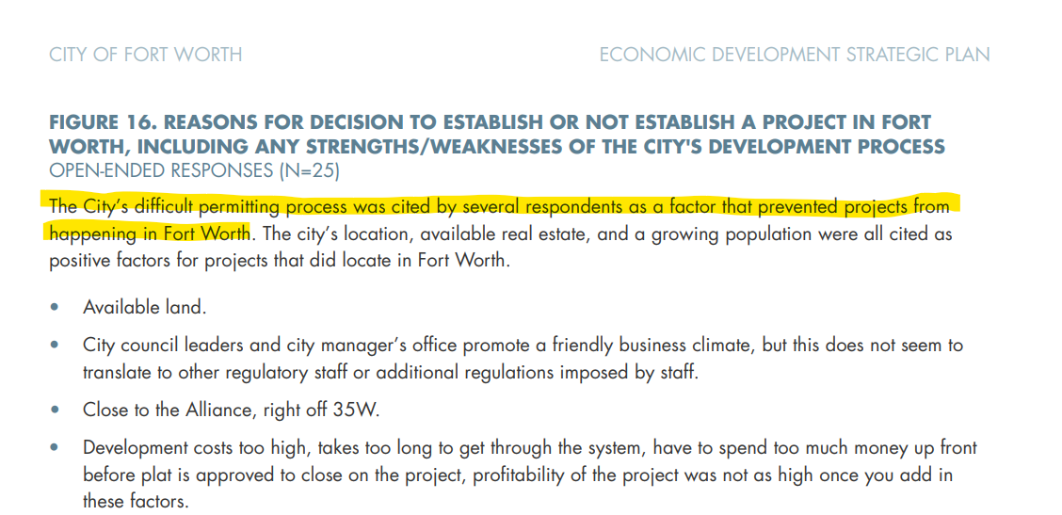
  + *“Most city staffs, including Fort Worth, struggle with turnover in the public facing and day to day staff, and therefore have consistency and execution challenges. Plus, this economy is so active, everyone is very busy.”*
  + One of the chief complaints appears to be the development process. Though I assume developers will **always** complaint about any form of process, this could be a good tie-in for data I analyzed. At the least, the data is dirty, which points at a less-than-ideal software being used for it.
  + 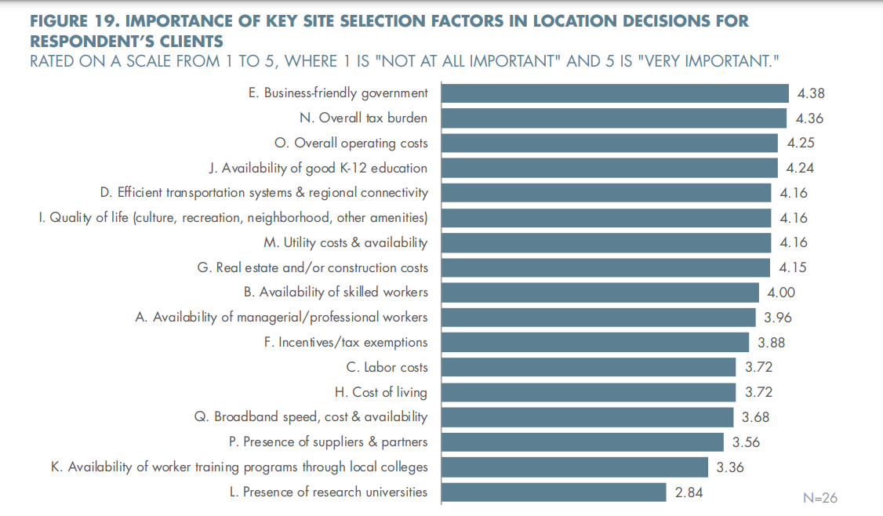
  + This quote was of particular interest:   
      
    ***FIGURE 22. WHAT IS THE MOST IMPORTANT THING THE CITY OF FORT WORTH CAN DO TO EFFECTIVELY MARKET THE CITY TO EXECUTIVES THAT YOU WORK WITH? OPEN-ENDED RESPONSE (N=20)*** *“Shake up the bureaucracy that currently exists at city hall... It is very similar to the problems that existed in Ft. Worth back in the 70's, when Ft. Worth had a great mayor and city leaders, but was issuing just over 100 building permits a year, and Ft. Worth's work force was moving into neighboring cities. Then City Manager, formed an over-site committee, that included the three largest developers in town. When the Ft. Worth Water Department and Park Department were dragging out permits ... They had the opportunity to explain their delays to the City Manager. As a result of that 1st. Development Policy Review Committee, developers were better able to design and build large-scale projects in the city. While the Development Policy Review Committee still exists ... it is bureaucratically archaic at best. Too many chiefs from the city & not enough strong check-writers from the development community.”*
* *ATTACHMENT B. MARKETING REVIEW*
  + *“Differentiation is more important than ever, especially considering there are roughly 90,000 local governmental units in the US, many of which are seeking to attract attention from the same relatively small group of industry decision-makers. Clichéd and generic phrases are no longer sufficient for economic developers to market their communities. Fort Worth offers a wealth of unique assets and advantages to companies seeking a destination for business and investment; however, these unique attributes are not being communicated clearly and consistently across organizations. Fort Worth organizations engaged in economic development should be more intentional about developing language that communicates the distinct benefits of living and doing business in Fort Worth. Most importantly, the city’s assets as they relate to target industries must be placed front and center in the community’s marketing materials.”*

### 2024-11-15

#### Daily Summary

Comparisons of staffing levels in economic development relative to peers indicates the City is lagging.  
There is an abundance of staff dedicated to this effort in the Fort Worth Chamber, however.  
  
Which, makes me think a lot of these functions have simply been outsourced to the Chamber.  
Dallas also has similar staffing levels, and is doing far better which indicates other factors at play.  
  
There is a lot of talent within the area, though very little of it works from home. This metric is used in the report as a proxy for “Quality of life”.  
  
Fort Worth Independent School District (FWISD) also ranks very low related to other districts on the basis of standardized test scores, which could be a deterrent to companies moving to the area.

#### Notes

* *ATTACHMENT D. ORGANIZATIONAL REVIEW*
  + *“Based on available data, economic development staffing levels in Fort Worth and Dallas fall short of those found among much smaller metro area communities. According to this analysis, the Frisco EDC had the highest relative staffing levels, with 8.6 staff members per 100,000 population served. By contrast, the City of Fort Worth’s staff-to-population ratio of 1.7 ranks near the bottom third. However, it should be noted that the City’s 14.5 staff include functions such as MWBE that are typically not included as part of a city economic development department in most communities. The Fort Worth Chamber’s ratio of 3.2 is almost double the City’s.”*
  + 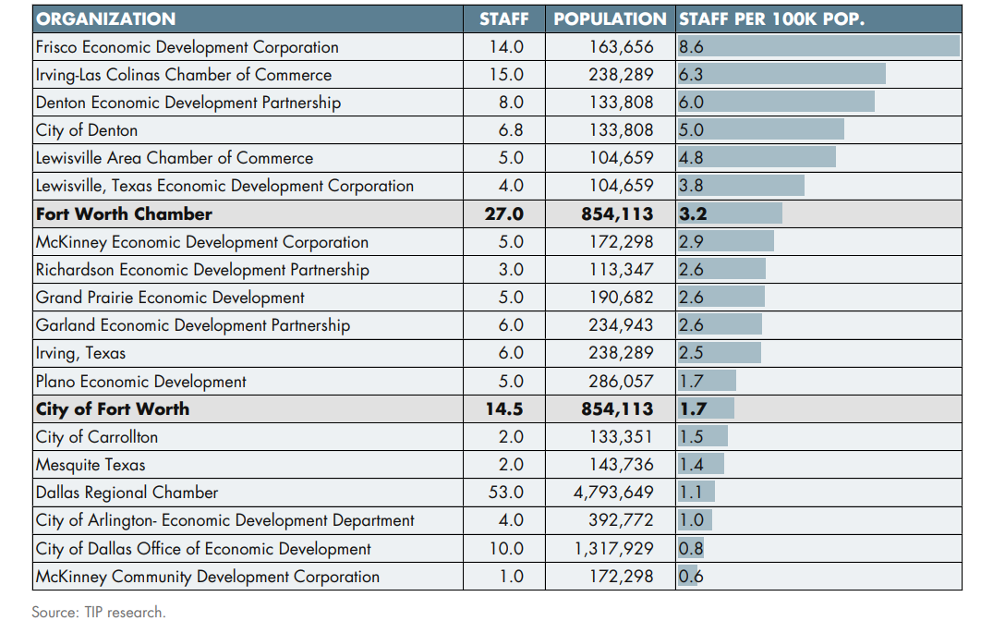
* *ATTACHMENT E. SITE SELECTION FACTORS*
  + 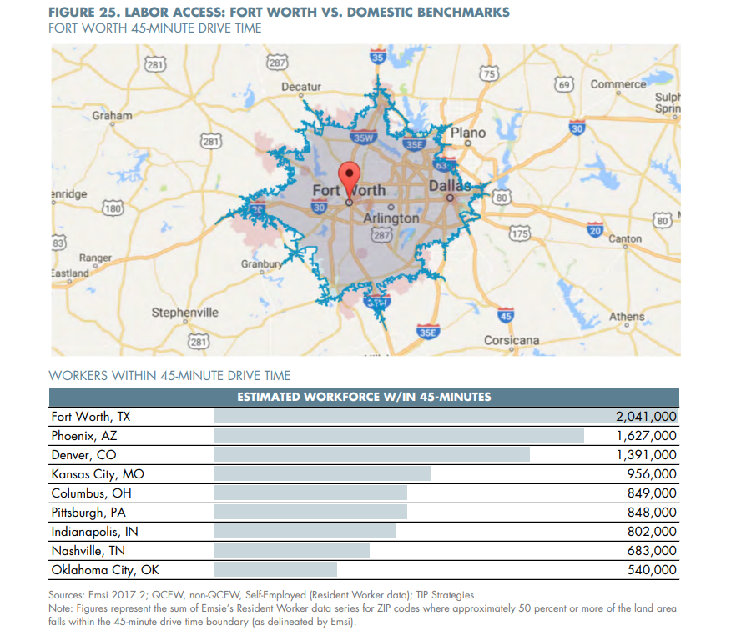
  + *“The definition of quality of life is very subjective, with little agreement on the best way to quantify an area’s performance on this important indicator. While crime statistics and school rankings are often used to gauge the desirability of a region, there are issues with these metrics. Despite its name, the FBI’s Uniform Crime Reports are criticized for lacking consistency in reporting protocols and definitions. Similarly, rankings of public education systems across states are not always an apples-to-apples comparison.   
      
    Moreover, when making comparisons across metro areas in different parts of the US, minor differences in crime or K-12 school performance rarely make or break a site location decision. The exceptions are places with notorious crime and/or school challenges that receive national media attention (such as Chicago’s crime outbreaks in recent years or Detroit Public Schools’ financial challenges). The issue of K-12 school performance will influence where a company decides to locate within a metro area. This issue is addressed in the next section (Dallas-Fort Worth Metro Area Comparisons).   
      
    Despite the challenges associated with attempts to measure a community’s quality of life, urbanSCALE.com argues that an objective measurement of quality of place does exist: the percentage of individuals who work from home within a given geography. It is worth noting that, while this indicator does a good job of “measuring” quality of life, it does not fit as a site selection factor in the same way as the previous nine of the top 10 factors given its subjective nature. Nonetheless, for this assessment, we have chosen to use a data-driven approach to understand the differences across metro areas.   
      
    This argument asserts that if a person can work from any location (and presumably, live in any location), why would they not pick the best location? Based on this assumption, the quality of life in an area can be judged by this one data point. The percentage of individuals who work from home demonstrates how individuals “vote with their feet.” The higher the percentage of at-home workers, the greater the quality of a place. The Fort Worth Metropolitan Division lags the nation slightly on this indicator and outperforms only Indianapolis and Oklahoma City among the domestic benchmarks. By contrast, rates in the Dallas Metropolitan Division exceed the nation. But Denver stands out among the pack as the having a much higher share of workers choosing to live and work from home.   
      
    Home prices can also serve as a measure of the demand to live in a particular place, although housing costs reflect several factors. Using this framework, cities with the highest-priced housing would be deemed to be among the most desirable. The assumption is that people who pay more for housing choose to do so because they gain more value from living in the area, despite the costs, than from living in a different area with more affordable housing costs. Data from the National Association of Realtors on the median sales price of existing homes suggest the Dallas-Fort Worth metro area is among the more desirable locations within the peer group.   
      
    Based on this measure, Denver is the clear “quality of life” winner, with median home sales prices that are 65 percent higher than the second-ranked market (Phoenix).”*
  + 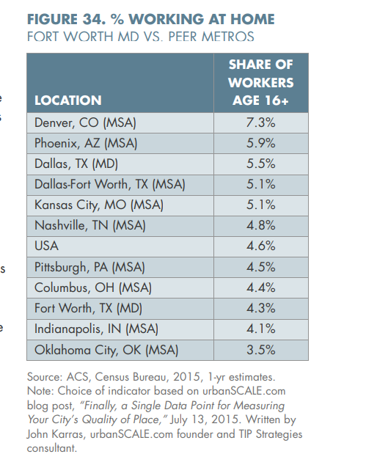
  + *“Although perceptions of school quality are not typically a critical factor in choosing between regions, they can have a tremendous bearing on corporate investment decisions within a region. This is particularly true for companies or industries for which the recruitment and retention of workers is paramount. In these site location decisions, close attention is paid to the performance of the primary K-12 school district serving a community. A worker relocating his or her family from Chicago to accept a new job in Fort Worth is more likely to look first at Fort Worth ISD as an indicator of the city’s school quality than Eagle Mountain-Saginaw ISD. The same can be said of Dallas, Irving, and other cities served by multiple districts. For this reason, the primary school district serving each of the competitor communities is used for comparative purposes. While there is no general agreement on the best measure, standardized test scores are used in the analysis as they provide a common data point for evaluating relative performance across districts and communities. Fort Worth ISD has the lowest performance among the competitor cities, followed by Irving and Dallas. Frisco ISD is the highest performing district, followed by Plano and McKinney.”*

## COFW Economic Development Strategic Plan Update (2022)

### 2024-11-18

#### Daily Summary

The 2022 update to the economic development plan sees the introduction of a lot of language around DEI, and underserved populations. This is likely in response to the political climate at the time, and I am curious to see if this tone will continue in future versions of this report.  
  
There is a continued emphasis on class A office space development, and a renewed emphasis on access to public funds from the State or government for investments in infrastructure, as well as an effort to incentivize desirable development from businesses and developers in a targeted way with new funds.

#### Notes

* 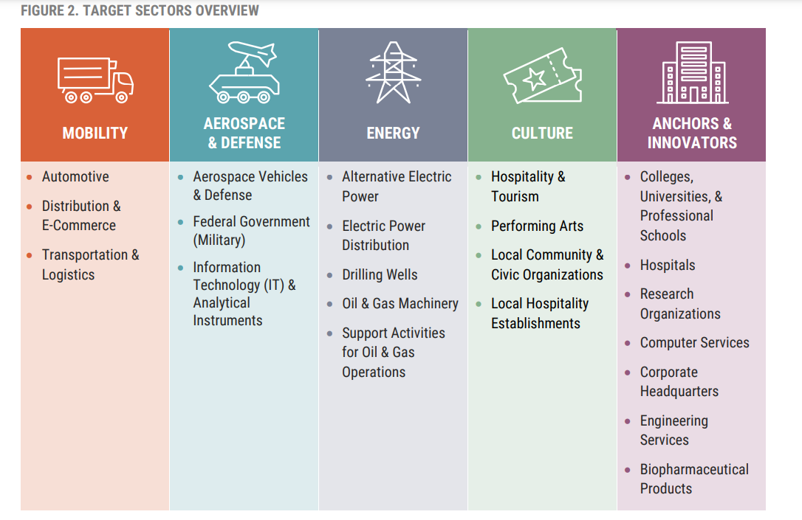
* *“With $1.9 trillion in funding, the American Rescue Plan Act (ARPA) of 2021 aims to respond to the COVID-19 emergency and address its economic effects, including aid to households, small businesses, nonprofits, and industries such as tourism and hospitality. 6 Of the $1.9 trillion, $195 billion is slated for states and $130 billion for local governments. The state of Texas has been allocated nearly $16 billion in ARPA funds, while Tarrant County and the City of Fort Worth have been allocated roughly $400 million and $174 million, respectively. Meanwhile, the federal Infrastructure Investment and Jobs Act (passed in November 2021) allocates roughly $35 billion to Texas over five years for roads, bridges, pipes, ports, broadband, and other infrastructure projects. This enormous influx of federal funds provides the City of Fort Worth the opportunity to invest in some of its most promising opportunities that can generate a sizeable impact for the local economy.”*
* *“The rise of industrial development is being driven by a convergence of factors, including supply chain restructuring driven by trade policy (tariffs and protection of national industries), vertical integration of multiple industries, and the just-in-time delivery model of products to businesses and consumers. These factors are increasing demand for industrial space for everything from warehousing and logistics to manufacturing and data centers. The need for new industrial construction is elevated across the entire US but is especially pronounced in the Dallas-Fort Worth metro area, which is emerging as the premier central US hub to complement New York and Los Angeles, surpassing Chicago’s long dominance as the major business and transportation hub in the middle of the country.”*
* *“The City of Fort Worth continues to be a net importer of workers with a 2019 labor force made up of 459,345 people. However, only one out of every three Fort Worth labor force participants (33.5 percent or 153,793) both live and work within the City limits. Unsurprisingly, Dallas is the next major employment destination for Fort Worth residents with more than 30,000 commuters. Despite an upward trend of Fort Worth residents commuting out of the City over the past 10 years, there is also an upward trend of workers commuting into the City for work over the same period. As of 2019, over 305,000 workers live outside of Fort Worth and commute to work inside the City, a 35.4 percent increase over the past 10 years. Most of these workers commute from Arlington, Dallas, Parker County, Grand Prairie, and North Richland Hills, in descending order.”*
* 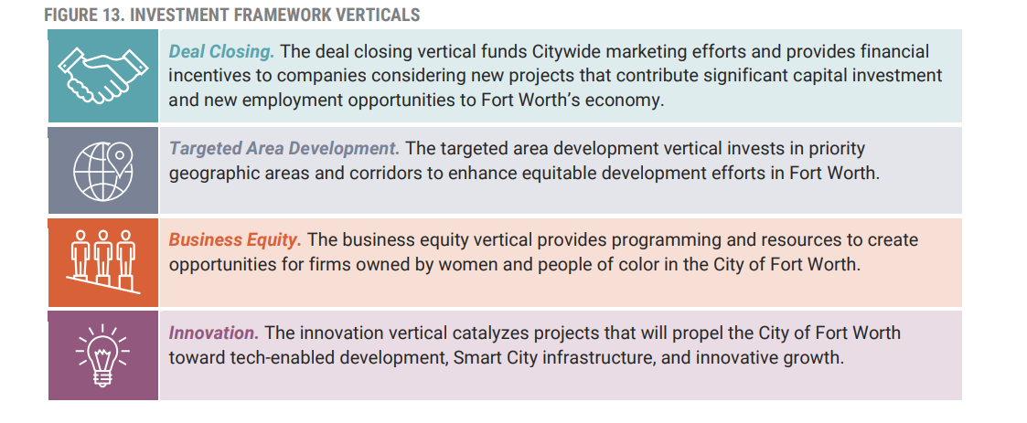
* *“Align deal closing fund processes with recommendations from the City’s Task Force on Race and Culture. • Incentivize projects that pay at or above median wages to raise the per capita income levels in the City. • Provide more aggressive incentives for projects in underserved areas.”*
* *“During the entrepreneurship and technology roundtable, participants identified access to capital as the least adequate existing resource for Fort Worth entrepreneurs. One opportunity to strengthen that is by engaging community development financial institutions to provide access to flexible and affordable financing options. These capital support programs must be intentional in supporting startups and small businesses owned and operated by people who identify as women, Black or of African descent, Latinx or Hispanic, Indigenous or Native American, Asian or Pacific Islander, and other persons of color.”*
* *“The US Economic Development Administration (EDA) can be a key source of funds for project implementation. For example, in August 2021, the EDA awarded a county in New Mexico over $1M to build fiber optic infrastructure to support business expansion. Caldwell, Texas, was awarded a $713,000 grant to fund roadway, water, and sewer infrastructure to support the development of an industrial park”*

### 2024-11-19

#### Daily Summary

City attracted a grant to invest in stop 6, retained a marketing firm to position Fort Worth for site selectors, and expanded/reorganized the department of economic development within the city since the adoption of 2017 strategic plan.

The 2022 update calls for increased attraction of employees, and school and company partnerships to attract and upskill employees into higher wage jobs that will be in demand in the future within the target areas for the city.

There is a new equity lens that been placed on equity through including it as a criterion in bond elections. There is also the first mention of the Fort Worth Task Force on Race and Culture.  
  
Upon further research, it seems the task force was a responsive measure due to public outrage and no longer exists.  
  
*“The formation of the task force followed a viral video involving Jacquelyn Craig, a mother whose incident with a Wort Worth police officer triggered backlash regarding police brutality. Craig passed away last week She was acknowledged during the meeting….  
  
  
“The task force has since been disbanded.”*- 2023-09-19  
  
**Source:** <https://www.fox4news.com/news/fort-worths-race-and-culture-task-force-progress-has-been-made-but-still-room-for-improvement>  
  
There is also mention of attracting a greater share of businesses which do business and employ people outside of the city, as opposed to those which are necessarily local; as well as working with local businesses to help them export their goods, using local breweries and other examples as case studies.

#### Notes

* Report encourages attracting talent and partnering with colleges to increase output of students and expand educational opportunities to skills that will be in demand by local industries. This is paired with a strategy of increased student housing and college footprint development plans.
* There are plenty of metrics and data sources given in this report to measure progress, though many rely on JLL, a good majority are publicly available.
* *“Finally, the City has witnessed massive industrial progress in recent years with nearly 15 million square feet of current industrial development. This is in part due to the City’s efforts to ensure protections for significant industrial districts with concentrations of manufacturing, transportation, and warehousing businesses. The City has also worked with other City departments to include economic development priorities as part of the review process and has supported owner-initiated zoning for industrial districts and adjacent areas.”*
* *“The City of Fort Worth has also propelled neighborhood projects to support community vitality. In early 2021, the US Department of Housing and Urban Development granted a $35 million Choice Neighborhoods Implementation Grant to transform the Stop Six neighborhood in Southeast Fort Worth. Building on the pre-existing assets in Stop Six, this funding will primarily be used to build modern, mixed-income housing. The funding will also provide community resources, public amenities, and neighborhood services to revitalize a long-neglected neighborhood. Meanwhile, the Evans & Rosedale area is also planning forthcoming development in its urban village. A master developer will begin working to transform the area into a mix of urban living and neighborhood retail with gathering places and green spaces.”*
* *“For the first time, the City is including equity as criteria in the May 2022 bond election. With guidance from the Fort Worth Task Force on Race and Culture, the City is evaluating bond projects on their ability to eliminate racial and cultural disparities. This is a step in the right direction to ensure that the City of Fort Worth is working toward building a more equitable economy. Additionally, since the adoption of the 2017 plan, the City Economic Development Department was reorganized and expanded for greater organizational impact and stronger partnerships with other economic development entities, like Visit Fort Worth. Yet, there remains even more opportunity for collaboration.”*
* *“Increasing the ratio of traded-to-local clusters is a common strategy for enhancing economic prosperity. Traded clusters are emphasized by economic developers because they include industries and firms that typically produce goods and services for customers beyond the local region. These traded activities are thus more likely to produce externally generated revenues, which can, in turn, help boost local tax coffers. As an example, a dental office might serve local customers exclusively, while a manufacturing plant, a data center, or a hotel would typically serve paying customers beyond the local area. The ability of traded clusters to serve larger markets also presents greater opportunity for employment growth, whereas a dental office might face more finite geographic limits to expansion.”*

## COFW Comprehensive Plan (2023)

### 2024-11-20

#### Daily Summary

Looks like permit values and types can be a good indicator of economic development.  
A lot of federal funding has gone into development in the city.  
  
They city seems to be pursuing a specific pattern of development throughout the area, which is interesting. Emphasis is placed on public parks and transportation.

#### Notes

* 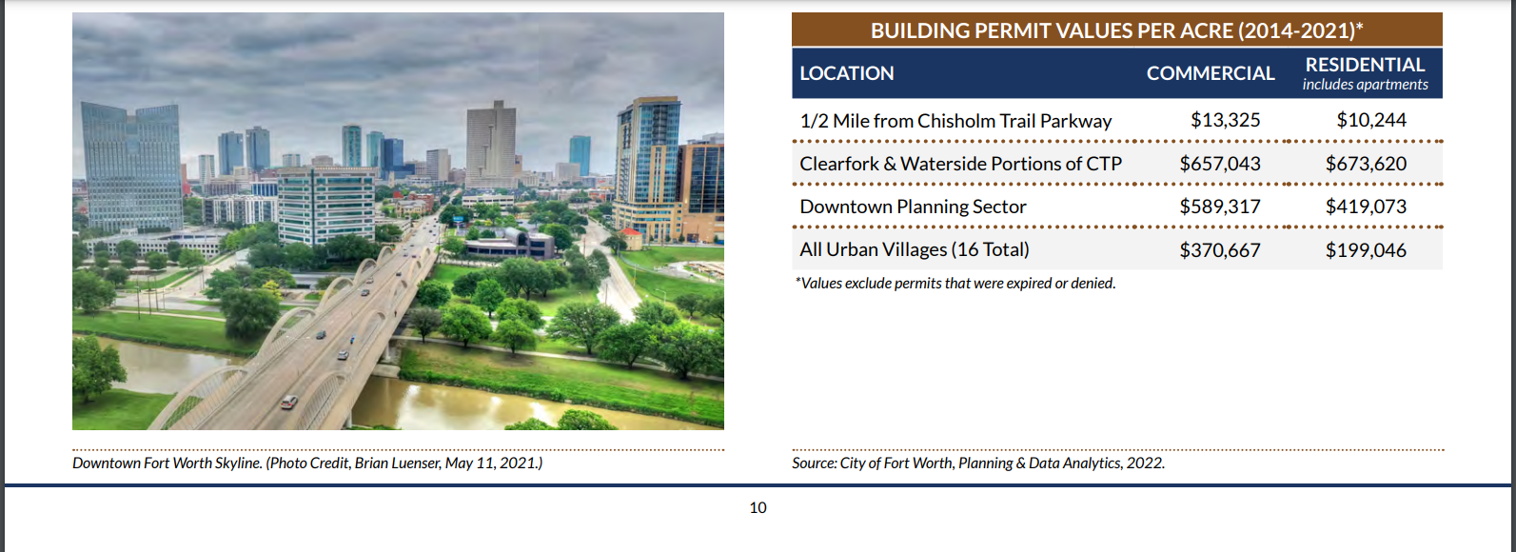
* 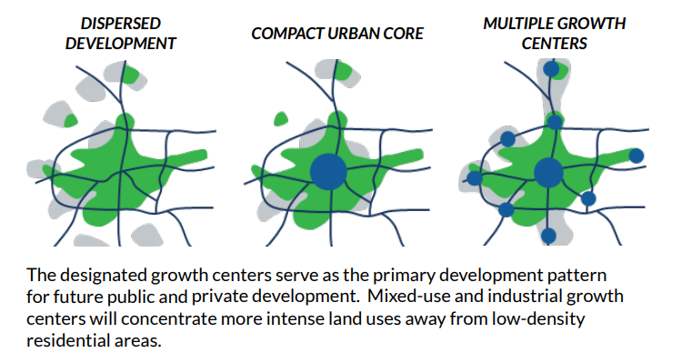
* *“The City has developed several policies and strategies related to promoting a multiple growth center development pattern, including the following: Policies • Locate multifamily units within walking distance of public transportation, employment, recreation, and/or shopping to increase accessibility and decrease vehicular traffic (p. 4-15). • Link growth centers with major thoroughfares, public transportation, trails and linear parks (p. 4-15). • Locate large industrial uses along rail lines, highways, or airports within industrial growth centers and other appropriate locations (p. 4-17). Strategy • Plan for, facilitate, and aggressively pursue appropriate transit-oriented development (TOD) at existing and future transit station locations. A TOD encourages compact urban development adjacent to transit stations. Mixed uses in a single building, minimal setbacks, and taller structures help achieve the higher densities necessary to support transit. Retail businesses and services for commuters should be located adjacent to transit stops, between the rail platform and parking facilities (p. 4-18).”*

### 2024-11-21

#### Daily Summary

The city of Fort Worth has been engaging in planning processes since its inception.  
  
The last major overhaul was the 2000 plan, with an update each year since. The process is opened up to citizens each fall.  
  
The city manager uses this yearly plan to formulate a yearly comprehensive business plan, which department heads use in turn to formulate their own business plans for the year, aligned to city council priorities and the comprehensive plan.  
  
The plan should be referenced by all stakeholders, and inform zoning and thus development within the city.

#### Notes

* 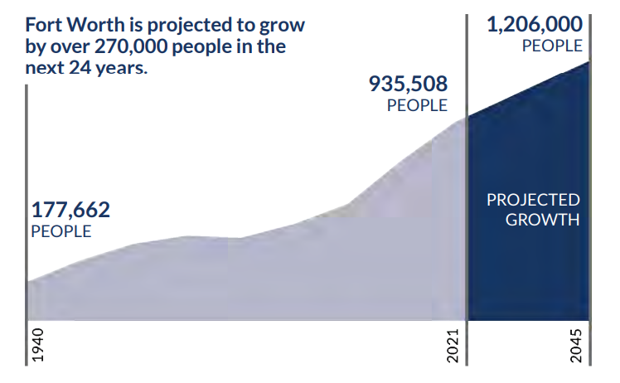
* *“Fort Worth’s rapid population growth can result in many different patterns of development — some more desirable than others. A current, updated comprehensive plan is essential to improving our community and making successful decisions about Fort Worth’s growth and development. Fort Worth’s 2023 Comprehensive Plan updates, extends, and enhances the vision of Fort Worth’s future that was originally expressed in the 2000 Comprehensive Plan, while also providing an updated policy framework to guide the decisions that will shape the city for years to come.”*
* *“Fort Worth has a rich history of planning. The City has taken hold of its future since its inception, from the commissioning of the outpost and the original town plan, to the creation of some of the first city plans in the country. The Kessler Plan of 1909 laid out some of the first city parks, lakes, and boulevards. In 1923, the first City Plan Board was created, and two years later the City Plan Commission was established by ordinance.”*
* *“Among the Commission’s first tasks was retaining Harland Bartholomew and Associates of St. Louis to create the 1927 Major Thoroughfare Plan, beginning with a boulevard and parkway system. In 1956, Victor Gruen and Associates produced a world-renowned plan for a walkable downtown. For the first time, a comprehensive plan was produced by City staff in 1965. This planning effort incorporated substantial citizen participation over a seven-year period and resulted in specific area plans for sectors and districts. These sector and district plans were updated in the early 1980s, again with significant input from the citizens of Fort Worth.”*
* *“The first major update of Fort Worth’s Comprehensive Plan began October 15, 1998, with a citywide forum attended by over 200 interested citizens. Following the forum, approximately 700 citizens attended 16 sector meetings held over a four-week period. Additionally, nine focus group meetings drew 160 citizens to provide input on specific issues, and presentations were made to civic organizations throughout the planning process. City Council and City Plan Commission members were a significant part of this process, moderating public meetings and informing citizens. This intense effort resulted in the receipt of over 1,000 comment cards from citizens wishing to express their concerns and suggestions. City staff incorporated comments and released the plan to the public in libraries, community centers, and on the Internet. Sixteen sector workshops and several focus group meetings were held again. After incorporating public comments, the plan was revised for public hearings held by the City Plan Commission and the City Council in early 2000. The Plan was adopted by the City Council on August 1, 2000, as a guide for Fort Worth’s growth and development.”*
* *“In October 2000, the City Council authorized staff to update the plan annually so that it continues to be a useful guide. The annual public review process starts in the fall when City staff conduct a series of community meetings to receive comments on the Plan. This process culminates with the adoption and release of a revised document the following spring.”*
* *“These strategic goals, along with the vision statement in the Comprehensive Plan and financial policies, help guide the City Manager in formulating an annual Consolidated Business Plan, which in turn provides the framework for department business plans and individual performance plans. Each City department prepares an annual business plan describing their mission and vision, organization, budget, major initiatives, and performance measures. The business plan relates the department’s activities to the City Council’s strategic goals and to the City’s organizational priorities: communication, customer service, and diversity. The business plan also relates the department’s activities to the goals, objectives, policies, programs, and projects contained in the Comprehensive Plan. This strategic alignment of the planning and budgeting processes, combined with continuous public input, helps to ensure that the City of Fort Worth provides the best possible service to its citizens.”*
* *“The comprehensive plan is described as a plan for the orderly growth and development of the city and its environs. The plan should “facilitate the movement of people and goods, and the health, safety and general welfare for the citizens of the city.” Section 25-55(7) requires that the City Plan Commission advise the Zoning Commission on the location of uses, height, bulk of buildings, and the division of the city into zones to carry out the goals of the comprehensive plan. A current and realistic comprehensive plan based on existing conditions and trends, as well as goals and objectives of the City, is essential to the effective growth and development of Fort Worth.”*
* *“The 2023 Comprehensive Plan is the twenty-third update of the 2000 Comprehensive Plan, a dynamic and evolving working document that is updated each year to assure its usefulness and relevance to the community. Changes to the Plan reflect shifts in demographic and economic trends that occur over time, as well as changes in policies, strategies, programs, and project status.”*
* 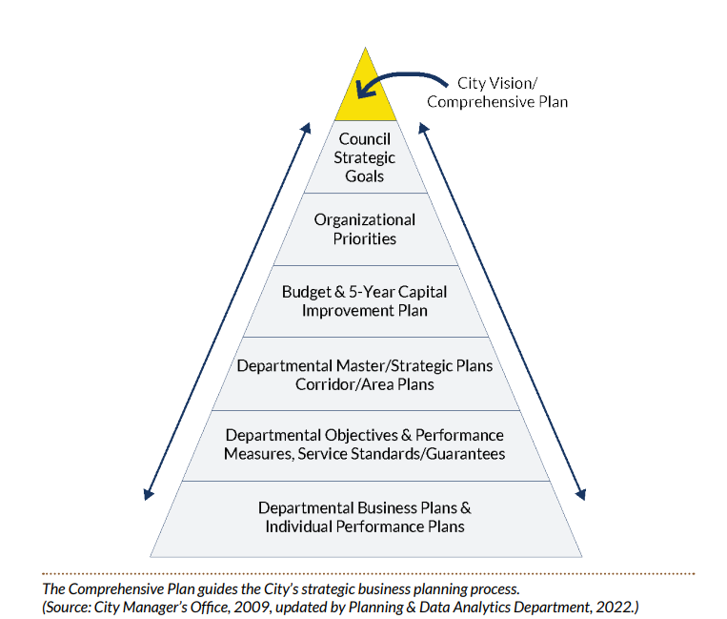

### 2024-11-22

#### Daily Summary

Early FW seems to have made money in agriculture and oil, then aviation/military.  
This timeline will be interesting to flesh out in combination with how we got railroads.

#### Notes

* *“Aviation History and Technology We value our rich aviation history and contributions to aviation technology, from the first air show organized by Amon G. Carter in 1911, to the manufacture of Joint Strike Fighters at Lockheed Martin Aeronautics Company. We value our aviation role in national defense, as home to the U.S. Army’s aviation training camp at Camp Bowie during World War I, to Carswell Air Force Base during the Cold War, to today’s Naval Air Station/Joint Reserve Base. We want our municipal airports to continue to contribute to the region’s economy. As the headquarters location for American Airlines and Bell Helicopter Textron, the world’s largest manufacturer of helicopters, we value our partnership with the aviation industry.”*
* *“Protection of Property Rights The plentiful supply of land and the independence it symbolized attracted pioneers to settle Fort Worth. Our economy thrived, first on agriculture and then on oil. Land and its ownership were seen as wealth or a means to wealth. A strong connection was perceived between economic independence and the ownership of land. Though our economy has diversified, the traditions and attitudes shaped by our history are strong. We want to choose how we use our land, as long as it does not negatively impact a neighbor’s use of property.”*
* 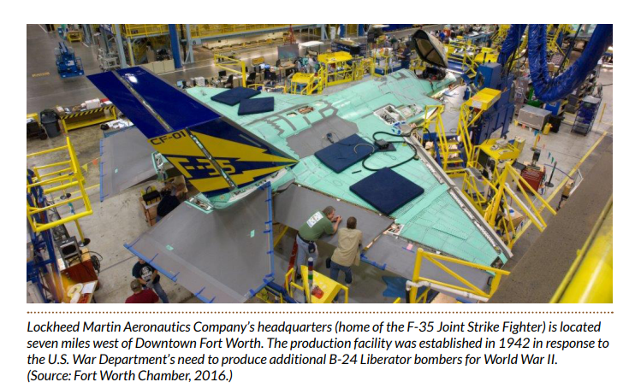

### 2024-11-25

#### Daily Summary

The comprehensive plan uses permit data to show the value of issued permits and their distribution amongst asset classes.  
  
It notes the local economy being driven by aerospace and defense contracts in the 70s and 80s, then diversifying in the 90s. The largest employers are still in aviation and military amongst others, however.  
  
Measures of household prosperity given are median income and per capita retail sales, amongst others.  
  
The largest contributors to the city’s revenue are property taxes (predominantly residential) and retail sales taxes.

#### Notes

* *“The present day prosperity of Fort Worth is linked to domestic and international changes in the past. During the 1970s and 1980s, the local economy was driven primarily by a large and successful aerospace and defense industry. Substantial cutbacks in defense contracts prompted the City to begin working towards diversifying its economy in the 1990s, largely through small business development. The result is an economy that is diversified in many industry sectors such as services, trade, manufacturing, transportation, communication, and construction. This diverse employment base helped Fort Worth weather the 2008 Great Recession and is foundational to Fort Worth’s ability to rebound from economic impacts of the Coronavirus (COVID-19) pandemic. The economy surpassed pre-pandemic employment levels during 2021 and saw notable expansion in 2022. Fort Worth’s robust economic growth is expected to continue over the next five years and beyond”*
* 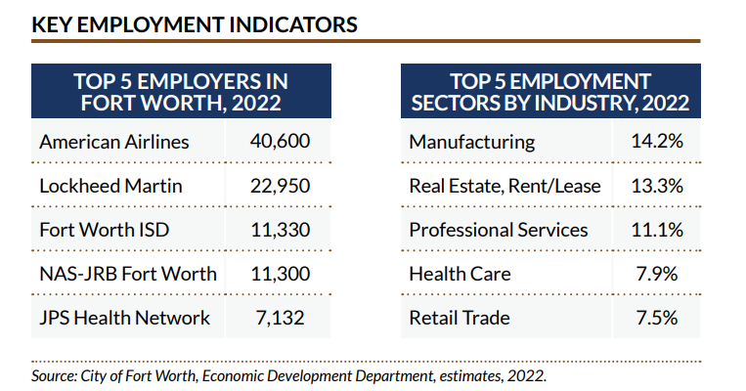
* *“Single-family residential development comprises the majority of the City’s building permit activity, which correlates to Fort Worth’s population growth. Commercial building permits have fluctuated annually over the past decade, with a high in 2012 and a low in 2020. Multifamily building permits have increased steadily over the past ten years, with the 2022 total more than doubling the previous peak in 2016.”*
* 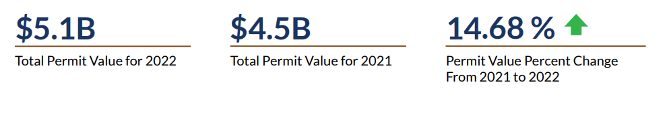
* 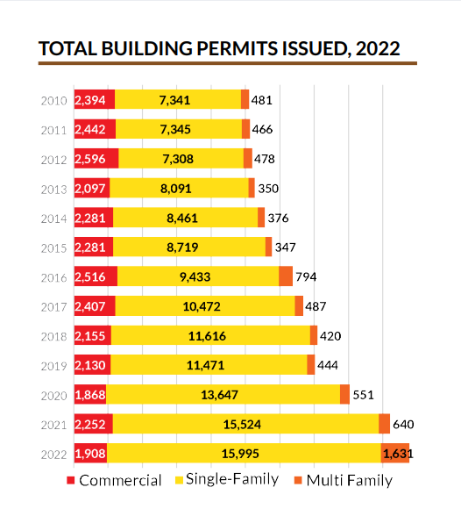
* 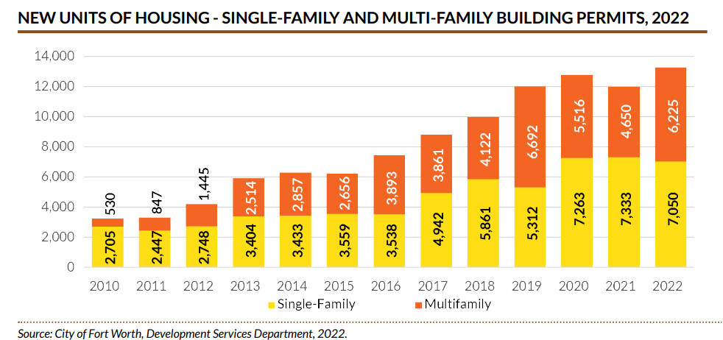
* 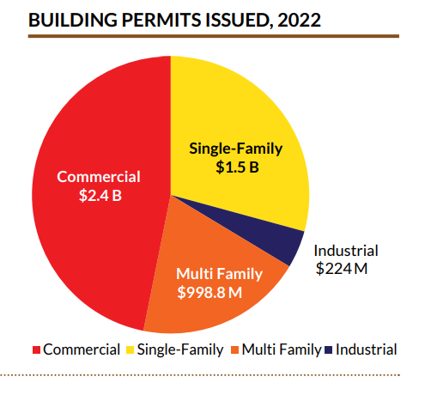
* **I should use the above figures in validation and reporting on permit data**
* 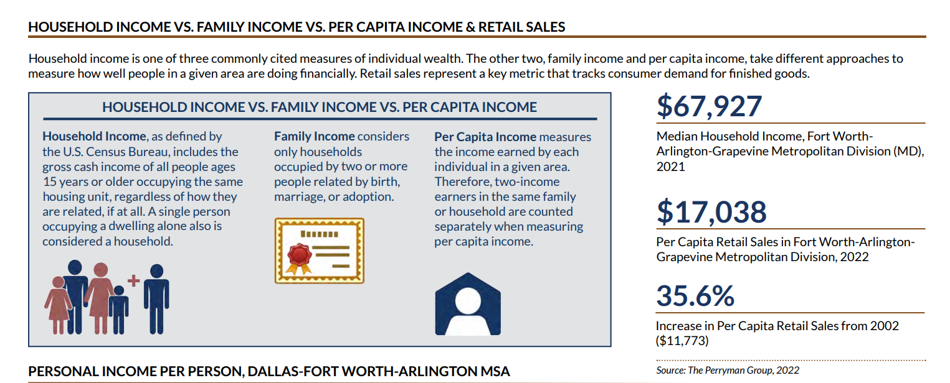

### 2024-11-26

#### Daily Summary

Re-iterated the need for lessened reliance on residential tax income, and underscored the goal of guiding development into a *“Multiple Growth Center Development Pattern”*.  
  
Placing schools in neighborhoods, increasing housing density and proximity to work and other activities as well as parks and public transit would encourage residents to rely less on automobiles.  
  
This is proposed to have the effect of tempering traffic and its associated environmental impacts, as well as relying on existing infrastructure such as roads, water and public services, making the use of said services more efficiently and at higher ROI than a *“sprawl”* type of development.  
  
Controlling the transition between uses, and accounting for constraints such as noise near airports, or floodplains is also discussed.

#### Notes

* *“An understanding of Fort Worth’s land use and zoning puts into perspective the City’s development history and how Fort Worth may continue to develop. Single-family housing, and manufactured housing occupies the greatest amount of developed land area in Fort Worth. In recent decades, development has often occurred in a leapfrog fashion, leading to a pattern of land uses that is irregular, non-contiguous, and less efficient and cost-effective to serve than is desirable.”*
* *“Fort Worth is one of the fastest growing amongst the 20 largest U.S. cities. From 2010 to 2020, Fort Worth permitted almost 44,000 new single-family housing units, with slightly over half of that total occurring just since the beginning of 2017. During the same period, Fort Worth permitted over 34,000 multifamily units, with over 57 percent of the total occurring within the last four years.”*
* 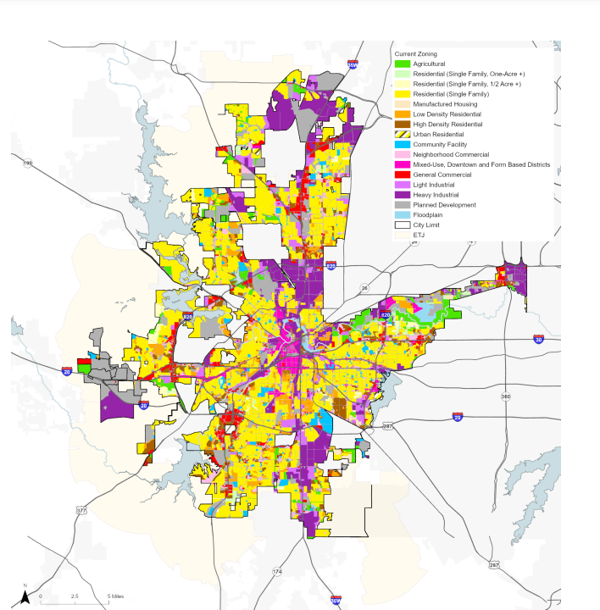
* 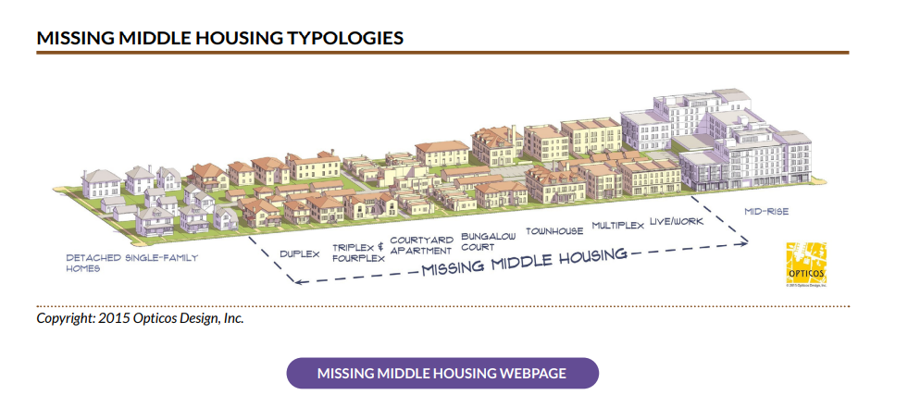
* From this graphic, it would appear the city believes it needs **more** 2-4 plex properties.
* *“Growth centers are located along highway or rail corridors to facilitate transportation linkages to other growth centers. A network of growth centers can accommodate citywide growth with fewer environmental impacts, less land consumption and traffic generation, and less pollution than a dispersed development pattern. The North Central Texas Council of Governments is also promoting this growth strategy in response to growing concerns over traffic, pollution, and reduced funding for transportation infrastructure.”*
* *“Prioritizing development within mixed-use growth centers is critical to building a financially sustainable future. Urban infill development uses existing public infrastructure (roadways, water, and sewer) making it less expensive to build and maintain the development long-term. Population density, encouraged by mixed-use centers, allows for the efficient use of public services (police, fire, public transportation); which improves quality of service while reducing expenditures. Overall, mixed-use growth centers and urban villages generate more tax revenue than they consume through use of city services and infrastructure.”*
* 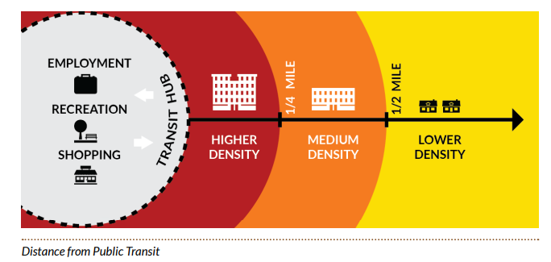
* *“Separate incompatible land uses with buffers or transitional uses. Some land uses have attributes such as height, proportion, scale, operational characteristics, traffic generated, or appearance that may not be compatible with the attributes of other uses.”*

### 2024-11-27

#### Daily Summary

Prices for homes and rental rates have steadily risen as the city has gown. This has led to a significant burden on low-income populations, especially people of color.  
  
These populations tend end up in overcrowded and substandard housing that has fallen into disrepair and tends to be older.  
  
The city makes proposals to HUD for funding to address these concerns, and plans to move away from areas of “concentrated” poverty, to providing housing in “mixed-income” neighborhoods with proximity to jobs and ideally better infrastructure.   
  
One such plan is underway for the stop 6 neighborhood, with $35 million in federal funding.

#### Notes

* *“Between 2011 and 2019, homes under $150,000 went from 67.1 percent of the market to 6.9 percent of the market. The rapid pace of cost increases underscores the urgency of dealing with the overall issue of affordable housing. In order to encourage first-time homebuyers to locate in Fort Worth, actions to assist them should be considered.”*
* *“While 33% of all Fort Worth households pay over 30% of their gross income for housing, 45% of African American households pay over 30% of their gross income on housing”*
* *“An estimated 13,000 Fort Worth households live in overcrowded conditions or substandard housing, i.e. without a complete kitchen or plumbing in their dwelling unit. Of these households, 7,600 or 59% are Hispanic.”*
* *“Concentrating people with lower incomes in neighborhoods with aging homes and infrastructure adds to the challenges faced by people who need affordable housing. These neighborhoods may have lower quality of life because of aging or inadequate infrastructure and the potential for disinvestment by neighboring property owners. They may be less likely to have the characteristics that support a healthy lifestyle, like parks, sidewalks and access to fresh food.”*
* *“Housing policy is influenced by Annual and Five-Year Consolidated Plans, which the City Council adopts for submission to the U.S. Department of Housing & Urban Development (HUD), as local housing activities have traditionally been funded only through CDBG, HOME, and ESG grants from that federal agency. These HUD-required plans focus primarily on the housing needs of low and moderate-income residents and special needs or homeless populations.”*
* *“Missing middle refers to housing that accommodates more people than a single-family home but does not come in the form of a large apartment building. Typically it means anything from a duplex to a small apartment building but, significantly, it is housing that would blend in a residential neighborhood dominated by single-family homes. It’s called “missing middle” because many communities do not have very much of this sort of mid-range housing. As described in the Land Use chapter, missing middle housing can address market demand for smaller scale multifamily housing that is dispersed within and compatible with single-family housing. Missing middle housing provides solutions along a spectrum of affordability to address the mismatch between the available U.S. housing stock and shifting housing preferences, combined with the growing demand for walkability.”*
* *“Finalizing its shift from a traditional public housing model, Fort Worth Housing Solutions completed the conversion of 686 multifamily units through the U.S. Department of Housing and Urban Development’s Rental Assistance Demonstration (RAD) program in 2020. Under RAD, housing assistance funds are moved from a traditional public housing community to units scattered throughout a city — deconcentrating poverty as a byproduct. The conversion allows housing agencies to leverage public and private debt and equity to reinvest in public housing stock and fund needed capital improvements.  
    
  The RAD program allowed FWHS to help 412 individuals and families to relocate from the 1940s-era Butler Place community to homes of their choice throughout the city, improving access to job centers, quality schools, and high-opportunity neighborhoods with amenities. Butler officially closed in December 2020. FWHS is working with HUD, the City of Fort Worth and others to determine next steps for the property”*
* *“In April 2020, the U.S. Department of Housing and Urban Development awarded Fort Worth Housing Solutions and the City of Fort Worth a coveted $35 million Choice Neighborhood Initiative Implementation Grant to seed revitalization of a historic and overlooked neighborhood, southeast of downtown Fort Worth. The funds will be spread across six phases of mixed income, multifamily housing and are expected to leverage $345 million in additional investment for the community.   
    
  The related Transformation Plan calls for more than 1,000 units of new rental housing, infrastructure, and a community hub with an aquatics center. The hub could be funded through a future bond program and would house needed support services. Construction of the 174-unit Cowan Place senior living community, Phase I of the Initiative, is scheduled to begin in Spring 2021. The former Cavile Place public housing site will be home to the second, third, and fourth phases of residential development.”*

### 2024-11-28

#### Daily Summary

The city has funding and volunteers to work on initiatives to reduce homelessness within the city. They also outline several homebuyer assistance programs, and incentives do develop specific zones, and more affordable housing.

There is a standard in place for outdoor space per resident, and new developments over a certain threshold need to set aside space for parks, or pay a fee in lieu when under the threshold.

#### Notes

* *“Each year approximately 500 volunteers across Tarrant and Parker counties count the number of persons experiencing homelessness on a single night in January. On a given night in 2020, 2,126 persons experienced homelessness in Tarrant and Parker counties.”*
* 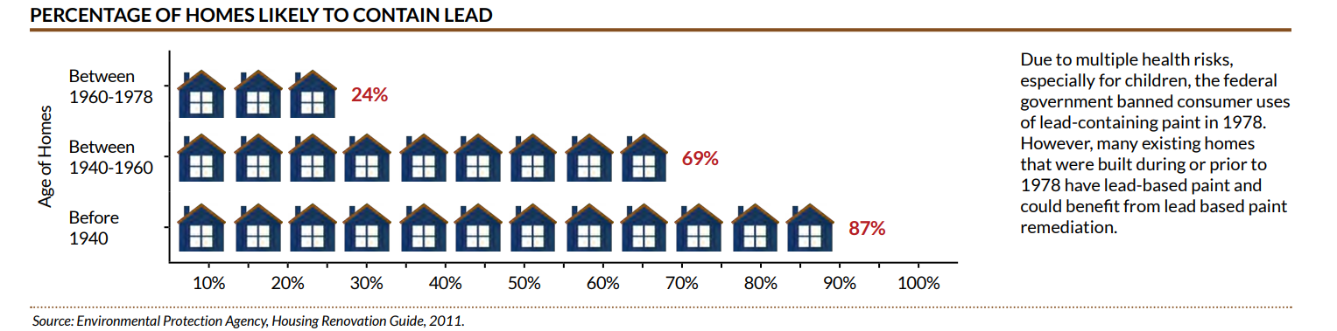
* *“A fee may be paid in place of the provision of parkland when the parkland dedication would be less than five acres. This results in a growing population, underserved by nearby parkland and with Citywide parkland acreage growing more slowly when new developments are below a threshold population. For example, parkland for new developments with 360 or more singlefamily homes are required by Policy to provide land for parks within the neighborhood (NPU or CPU), while parkland might not be provided (a fee would be paid) within new developments below 360 single-family homes. This threshold occurs at 1,530 persons, as illustrated in the chart Fee or Parkland.”*
* 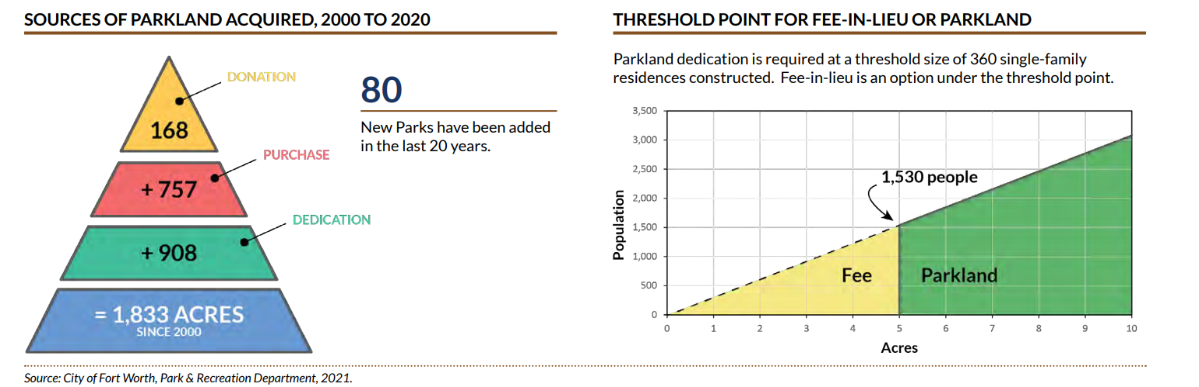

### 2024-11-29

#### Daily Summary

Urban forestry plays a role in permitting, and the department is charged with preserving trees in FW.  
  
Other departments provide athletic spaces, as well as community centers to promote an active lifestyle for city residents.

The city plans to expand trails and open spaces, as well as preserve floodplains as a benefit to residents and tourists.  
  
City libraries have benefited from Policy changes such as expanded hours and the removal of daily late fees.  
  
Access to library space per resident has decreased with population growth, and libraries are geographically concentrated in the center of the city.

#### Notes

* *“Urban forestry is the management of tree populations in urban settings for the purpose of improving the environment and providing aesthetic benefits. As stewards of the city’s green infrastructure, the Forestry Section administers the plan review and permitting process for any planting, pruning, or removal of trees from municipal property and enforces the city’s Urban Forestry Ordinance, which protects trees and works to achieve the city’s goal of 30 percent canopy cover.   
    
  The Forestry Section operates the 71-acre municipal tree farm, where trees are grown from seeds and acorns harvested from the best trees in the city. Crews offer citizen forestry training, volunteer opportunities and grants to provide trees to Fort Worth communities. When they are ready, the trees grown at the tree farm are transplanted to parks and public spaces throughout the city and maintained by the Forestry Section.   
    
  Additionally, the Forestry Section operates the Hazard Abatement program, caring for more than 250,000 trees in street rights-of-way and countless other trees in parks and other municipal property. Special events across the city such as the Arbor Day celebration, a tree giveaway booth at Mayfest, tree planting projects, and a variety of outreach events are hosted by the Forestry Section annually.”*
* *“In October 2019, the Library eliminated daily late fines for all ages. With this change, the Library saw a continued increase in the use of library services. We also looked at policies and procedures that created barriers or were inconsistent. For example, a change was made to increase the loan period for DVD’s. With this change, repeated checkouts of physical materials decreased.”*
* *“The average Fort Worth resident has access to less library space today than they did in 1980. Today’s library space is primarily located within or near the central part of the city. Residents inside Within Loop 820, approximately 40% of the population has access to 80% of the library space. However, the average age of libraries within or adjacent to Loop 820 is aging compared to branch libraries in growing parts of the city.”*

### 2024-12-02

#### Daily Summary

Not many notes today. Plans on expanding libraries, providing public assistance to low-income families, preventing child abuse/neglect and support the senior population are all discussed.

#### Notes

### 2024-12-03

#### Daily Summary

There are several initiatives aimed at increasing civic engagement. The city also promotes local neighborhood associations to galvanize citizens and serve as an interface with the city. Considerable funds are allocated to improving target neighborhoods, and an emphasis is placed on self-sufficiency.  
  
There is encouragement of volunteering and philanthropy though nonprofit organizations, many of which are faith based.  
  
Metrics for measuring success across these initiatives include neighborhood association count, members, and meetings; as well as permit value changes in target neighborhoods and “signals of distress” movement after a targeted initiative.

#### Notes

* *“The City’s Community Engagement Office offers the following adult education workshops that promote capacity building. The workshops range from 30 minutes to 2 hours.”*
* *“Neighborhood alliances are umbrella organizations that consist of multiple neighborhood organizations that organize to foster communication and/or advance common interests or initiatives.”*
* *“Redevelopment organizations are generally nonprofits that focus on locations that the private sector has bypassed. Their activities are varied but can include corridor redevelopment, business development, advocacy, and other activities.”*
* *“Faith-based organizations are religious organizations or places of worship whose mission and purpose includes outreach and assistance to communities in need.”*
* *“The Community Engagement database provides contact information pertaining to each organization registered with the city. The database is widely used by all City departments for public outreach. It is the key communication tool to keep organizations informed.”*
* *“The City of Fort Worth launched the Neighborhood Improvement Strategy (NIS) Program in 2017 to make strategic investments in distressed Fort Worth neighborhoods in collaboration with neighborhood associations and residents. The vision of the Neighborhood Improvement Strategy Program is sustainable neighborhood renewal that improves conditions and quality of life for residents.   
    
  The NIS program was initially funded by a 1/2-cent of municipal property tax but has evolved into an annual allocation from the operation and maintenance portion of the property tax funds for capital expenditures. Each neighborhood receives between $3M and $4M that is typically spent on capital improvements that significantly improve neighborhood physical conditions, such as sidewalks, street trees, lighting, police cameras, park improvements, and street repaving, as well as increased City services such as code enforcement and mowing. The selection of projects is made by neighborhood residents based upon their highest rated concerns for the neighborhood.”*
* 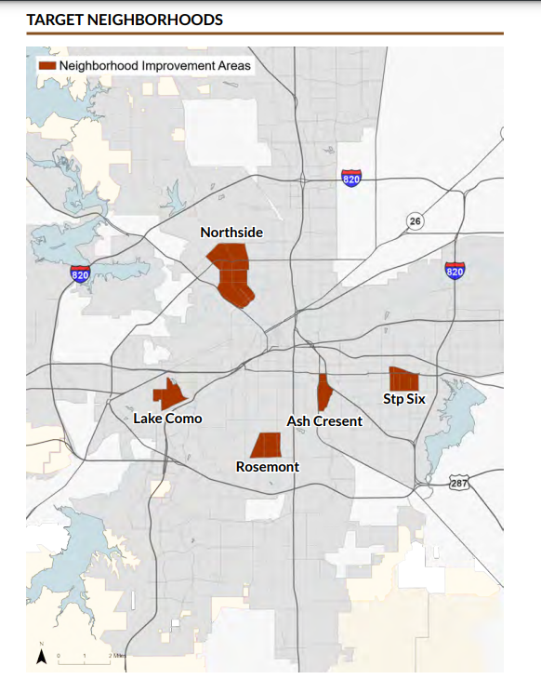
* 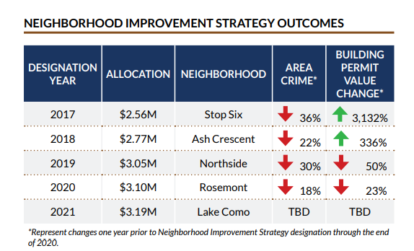

### 2024-12-05

#### Daily Summary

Several initiatives exist to promote the creation of local small businesses, such as the business assistance center. These businesses tend to create jobs, give a neighborhood personality, and recirculate more money in the local economy.  
  
TIF districts, Neighborhood empowerment zones, zoning decisions, and other policies and incentives work together to encourage desirable development in targeted areas. The city’s vision is one where citizens live, work and play in high-density areas and are able to rely less on cars.

#### Notes

* 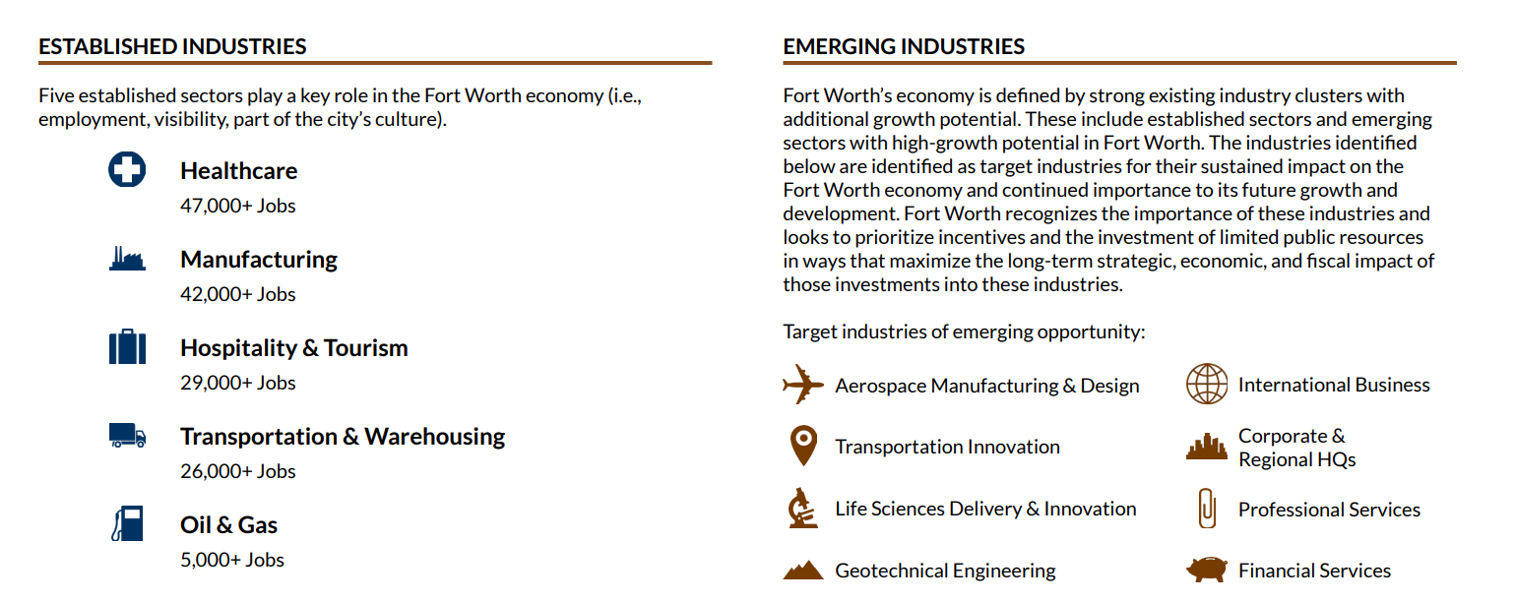
* *“Dynamic local economies are often defined by a strong base of independent, locally-owned, small businesses. Distinctive retailers, restaurants, and coffee shops help otherwise sterile corridors build unique identities. They also provide enhanced opportunities for minority and woman-owned business development. Independent, locally owned firms also recirculate a higher share of their revenue in the local economy compared to national chain businesses. Additionally, these businesses help attract tech companies and often become magnets for young people, even beyond the city limits. Supporting small businesses is critical to ensuring the vitality and uniqueness of our community.”*
* *“The James E. Guinn Entrepreneurial Campus (Guinn Campus), located at 1150 South Freeway in Fort Worth, is the city’s hub for small business and entrepreneurial development. The campus is a vibrant resource for current business owners and aspiring entrepreneurs within Fort Worth and surrounding counties who are looking to take their business to the next level. The campus consists of three distinct buildings: the Fort Worth Business Assistance Center, TECH Fort Worth and IDEA Works FW.   
    
  The Fort Worth Business Assistance Center (BAC) is an initiative of the City of Fort Worth Economic Development Department located at the James E. Guinn Entrepreneurial Campus. The BAC, supported by Accelerate DFW Foundation, Inc., provides a wide variety of training and counseling through eight partner organizations. The training workshops range from classes designed to help create new start-ups to classes to address day to day business operations.”*
* *“A Tax Increment Financing (TIF) District is a designated reinvestment zone for a limited number of years in which tax revenues exceeding the base year amount are used primarily for public improvements, but can also include services within the zone. TIF districts help fund public improvements which attract investment, create jobs, and diversify our economy.   
    
  A board of directors, consisting of 5 to 15 members who are representatives from the participating taxing entities and representatives of other areas as set forth in Chapter 311 of the Texas Tax Code, is established for each TIF. The TIF revenues are spent according to an approved project and financial plan for development of the designated reinvestment zone.”*
* 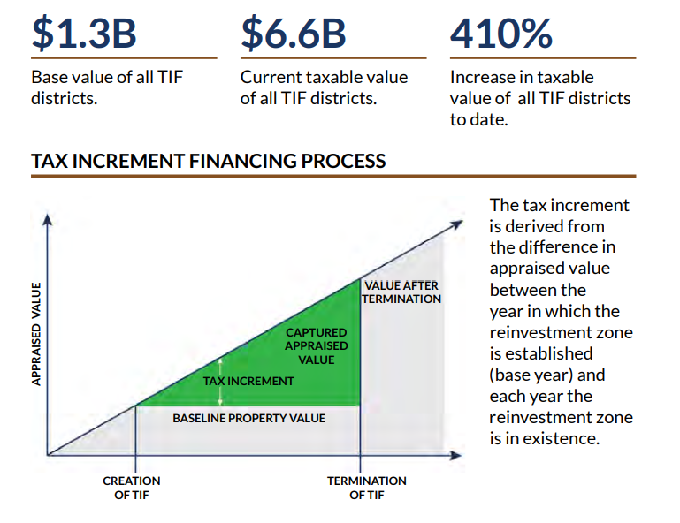
* *“Opportunity Zones are a new community development program established by Congress in the Tax Cuts and Jobs Act of 2017. It encourages long-term investments in low-income urban and rural communities nationwide. The Opportunity Zones program provides a tax incentive for investors to re-invest their unrealized capital gains into Opportunity Funds; funds that are dedicated to investing in state-designated Opportunity Zones. In March of 2018, the State of Texas designated 628 eligible low-income census tracts in 145 counties as Opportunity Zones. Six of the designated census tracts are located within the City of Fort Worth.   
    
  The Economic Development Department of the City of Fort Worth will assist investors in achieving a general understanding of the program and will promote the use of Opportunity Funds for investment in designated Fort Worth Opportunity Zones. In particular, the Economic Development Department may serve as a resource to local investors wishing to benefit from the program while also generating a positive impact on the local community. The City may likewise help to identify eligible project opportunities. Where appropriate, the use of local incentives and other economic development tools will be considered in support of qualified Opportunity Zone investments.”*
* 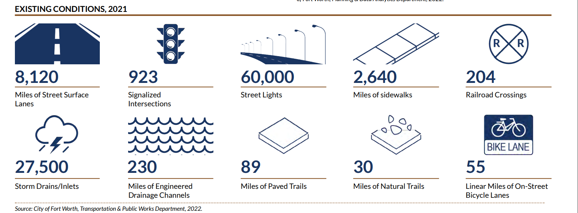
* *“Transit-oriented development (TOD) is an important component of sustainable development. TOD refers to a compact, walkable, urban village that is centered around and coordinated with a transit station in its use and design. The purpose of TOD is to establish land uses and to design structures and public spaces that will encourage residents, workers, and shoppers to drive their cars less while walking, cycling, and riding transit more.   
    
  In order to encourage mixed-use and transit-oriented development, the City of Fort Worth employs mixed-use and urban residential zoning classifications. These categories encourage mixed-use and higher density developments, especially in designated mixed-use growth centers and urban villages (see Chapter 4: Land Use). Mixed-use zoning significantly reduces parking requirements and provides urban design standards that are transit- and pedestrian friendly.”*

### 2024-12-09

#### Daily Summary

Roads are developed to guide traffic and promote safety. Lots of repeated material today. Finished on page 174.

#### Notes

* *“Fort Worth is developing into a major center for industry, technology, transportation, and government. The diversity of Fort Worth’s economy should continue to expand in various economic sectors, such as electronics, manufacturing, corporate headquarters and offices, finance, health care, transportation, education, and hospitality. Employment centers are areas with large concentrations of employees, including business parks, business clusters, and industrial parks. These centers are generally located in areas with access to major highways. Fort Worth has six significant employment centers: Downtown, Medical District/Near Southside, NAS-JRB/Lockheed Martin, CentrePort Business Park, Alliance, and Carter Industrial Park.”*
* *“Local and collector street networks support the street system by providing alternative routes from major thoroughfares for short trips. Without this collector street network, all local trips are funneled onto a few major streets, resulting in significant traffic delays and driver frustration. Collectors provide critical connections throughout the network and bridge the gap between local streets and the major thoroughfares of a community.   
    
  Reasonable connectivity of the local street network is also important. Fragmented street systems impede emergency access and increase the number and length of individual trips. Residential street systems must be designed in a manner that discourages “through” traffic across multiple neighborhoods, without eliminating connectivity.”*

### 2024-12-11

#### Daily Summary

Road quality, pedestrian and bike experience are all assessed using “objective” measures. Bike and pedestrian infrastructure improvements underway for Downtown,   
  
Technology is used in traffic and parking to manage congestion, ease parking experience and allow for informed future planning. Traffic signals and other measures can be coordinated with real time data to manage traffic flows.

Flooding is also measured and communicated in real time using data.  
  
Ended on page 185.

#### Notes

* *“The city pavement condition assessment is performed on a 3-5 year basis. The assessment determines the Pavement Condition Index (PCI) for each street segment based on the severity and extent of the pavement defects. The defects for asphalt streets may consist of ride quality, rutting, raveling/ flushing, alligator cracking, patching and transverse or longitudinal cracking. For concrete streets, defects such as ride quality, faulting, joint seal loss, joint spalling, scaling, patching, transverse and longitudinal cracking are evaluated. PCI is grouped into 6 categories: Failed, Poor, Fair, Good, Very Good, and Excellent. An Overall Condition Index (OCI) number is calculated for each street segment based on the PCI and flatworks (curb/gutters) condition and replacement percentage. The lower the number, the worse the overall street condition”*
* *“The Annual Street Maintenance Program assists in the maintenance of all City streets, including asphalt, concrete, and brick surfaces. Streets that are maintained through the program are selected each year based on citizen’s requests and staff evaluation of conditions. Some streets outside the city limits are also maintained through jointly funded interlocal agreements between the City and other jurisdictions.”*
* *“ITS uses technology and management strategies to ease real-time traffic congestion with the adjustment of traffic signal timing and the coordination of response activities with local or regional transportation and emergency services. Fort Worth’s ITS plan was developed in coordination with TxDOT’s regional ITS plan and in cooperation with NCTCOG. This plan includes: • Incident management system to provide timely information to responding agencies such as fire, police, and emergency medical services. • Coordinated traffic signal system to manage the timing of signals to improve traffic flow. • Methods to alert motorists of congested areas and offer alternative routes or modes of travel. • Traffic monitoring system to monitor system flow. As part of the ITS Communication Master Plan, the City installed cable modems and radio systems into several hundred intelligent transportation system (ITS) devices citywide. This allows the ITS devices to be managed from the City’s Traffic Management Center downtown.”*
* *“Fort Worth experiences rapidly moving storm fronts that can lead to hazardous flooding at roadways. The flood warning system in Fort Worth, also known as the High Water Warning System (HWWS), relies on real-time water level measurements at 52 of the most hazardous low-water crossing locations. Roadside flashers at these locations immediately warn drivers of the flood hazard. Email alarms are sent to first responders and emergency managers from the City, County, School Districts, the National Weather Service, and other partners when the water level sensors of each flasher system are triggered from rising water. First responders from the Stormwater Division of TPW barricade the roads to prevent vehicles from entering the flooded areas. Many of the locations without the flashers have road side flood warning signage.”*
* *“…Smart Parking Technology also provides the City with invaluable data used to plan for future parking needs.”*

### 2025-01-20

#### Daily Summary

There is a quantifiable way to ensure street quality, alongside driver, pedestrian and bicyclist experience on roads, and these methods are used to inform maintenance and development.  
  
Multiple modes of transportation and efficient parking drive lower emissions and reduced congestion.

The city also collects and publishes traffic and flooding data.

#### Notes

* 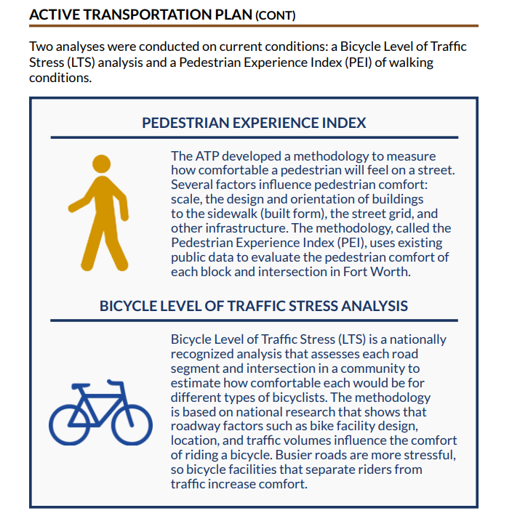
* 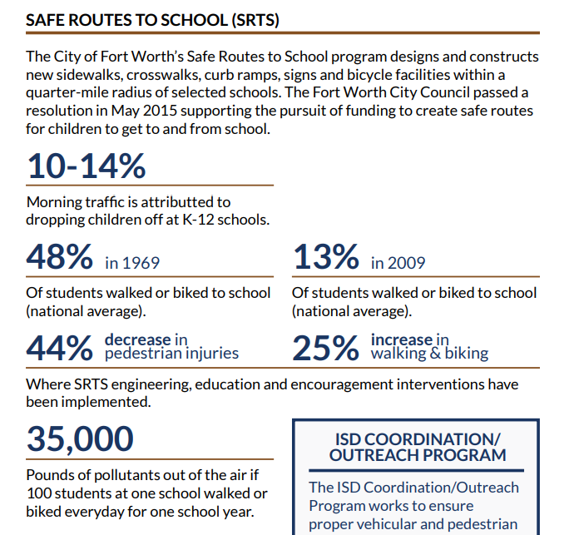
* *“The city pavement condition assessment is performed on a 3-5 year basis. The assessment determines the Pavement Condition Index (PCI) for each street segment based on the severity and extent of the pavement defects. The defects for asphalt streets may consist of ride quality, rutting, raveling/ flushing, alligator cracking, patching and transverse or longitudinal cracking. For concrete streets, defects such as ride quality, faulting, joint seal loss, joint spalling, scaling, patching, transverse and longitudinal cracking are evaluated. PCI is grouped into 6 categories: Failed, Poor, Fair, Good, Very Good, and Excellent. An Overall Condition Index (OCI) number is calculated for each street segment based on the PCI and flatworks (curb/gutters) condition and replacement percentage. The lower the number, the worse the overall street condition.”*
* 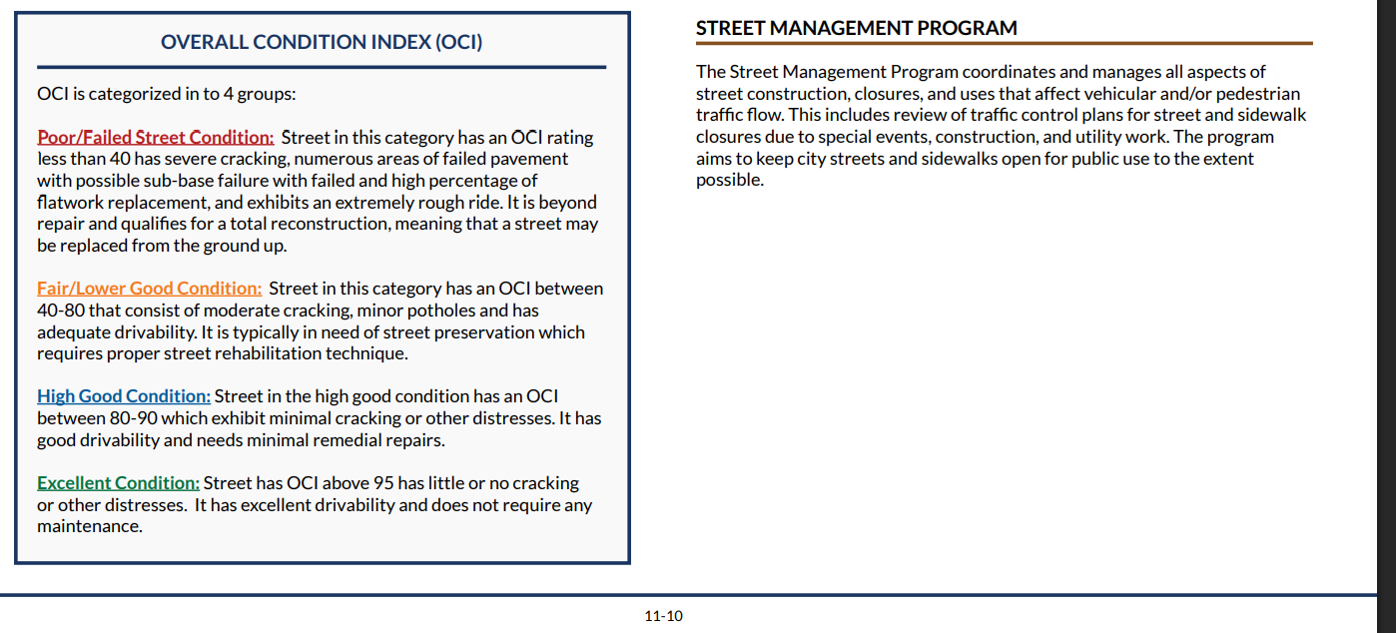
* *“The Annual Street Maintenance Program assists in the maintenance of all City streets, including asphalt, concrete, and brick surfaces. Streets that are maintained through the program are selected each year based on citizen’s requests and staff evaluation of conditions. Some streets outside the city limits are also maintained through jointly funded interlocal agreements between the City and other jurisdictions.”*
* *“The Street Management Program coordinates and manages all aspects of street construction, closures, and uses that affect vehicular and/or pedestrian traffic flow. This includes review of traffic control plans for street and sidewalk closures due to special events, construction, and utility work. The program aims to keep city streets and sidewalks open for public use to the extent possible.”*
* *“ITS uses technology and management strategies to ease real-time traffic congestion with the adjustment of traffic signal timing and the coordination of response activities with local or regional transportation and emergency services. Fort Worth’s ITS plan was developed in coordination with TxDOT’s regional ITS plan and in cooperation with NCTCOG.”*
* *“As part of the ITS Communication Master Plan, the City installed cable modems and radio systems into several hundred intelligent transportation system (ITS) devices citywide. This allows the ITS devices to be managed from the City’s Traffic Management Center downtown.”*
* *“Fort Worth experiences rapidly moving storm fronts that can lead to hazardous flooding at roadways. The flood warning system in Fort Worth, also known as the High Water Warning System (HWWS), relies on real-time water level measurements at 52 of the most hazardous low-water crossing locations. Roadside flashers at these locations immediately warn drivers of the flood hazard. Email alarms are sent to first responders and emergency managers from the City, County, School Districts, the National Weather Service, and other partners when the water level sensors of each flasher system are triggered from rising water. First responders from the Stormwater Division of TPW barricade the roads to prevent vehicles from entering the flooded areas. Many of the locations without the flashers have road side flood warning signage.”*

### 2025-01-21

#### Daily Summary

The city of Fort Worth is uniquely located and positioned as a logistic hub for the nation with the I-35 corridor, multiple airports, rail and other infrastructure.

There is discussion on how transportation system improvements are funded.

Our schools are doing terribly in reading. They say they’ll fix it.

There is ample discussion of historic preservation and its economic value, along with a section on urban design.

Overall, the city posits that preserving and restoring historic buildings, developing its transportation infrastructure to facilitate non-vehicular transportation, and encouraging pedestrian oriented, high-density development will lead to positive cultural, economic, and environmental outcomes.

Ended on pg.230.

#### Notes

* *“Dallas-Fort Worth International Airport (DFW), jointly owned by the cities of Fort Worth and Dallas, is a large hub airport serving the North Texas region, and providing nonstop service to over 200 cities worldwide. Opened in 1974, DFW is now providing an economic impact of $37 billion annually, supporting 228,000 full time jobs. DFW is the largest hub for American Airlines, which is headquartered in Fort Worth.”*
* *“Interstate Highway 35, which runs north/south through the center of Fort Worth, has served as the North American Free Trade Agreement (NAFTA) corridor since 2015. In addition to truck freight, national railroad corridors and air cargo hubs make the City a national logistics hub. Emerging technologies in vehicle automation are on track to influence how freight moves in the future.”*
* 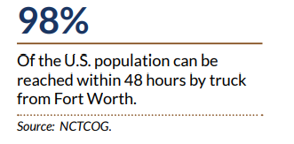
* *“Funding transportation projects can be categorized based on the project phase, target user, and funding source. A project’s type, such as roadway, bridge, intersection, trail, or wayside facility, can also affect which funding programs to target. Its location can affect this decision as well. When pursuing funding, smaller projects can often be grouped in with larger, more complex projects that may require a mix of funding sources. These sources include the General Fund, Bond Programs, Public Improvement Districts (PIDs)/Tax Increment Financing, federal funding, and private and nonprofit partnerships.”*
* *“The General Fund is the largest fund within the City with the largest amount of revenue in the overall City budget. The General Fund revenues include property tax; sales tax; operating transfers; charges for service; license and permit fees; fines forfeitures; and special assessment, and other miscellaneous revenues. The Transportation and Public Works Department is funded through four different funds: • General Fund • Stormwater Utility Fund • Municipal Parking Fund • Capital Project Services Fund”*
* *“Transportation improvements can often be included as part of larger efforts of business improvement and retail district beautification. Similar to benefit assessments, PIDs collect levies on businesses in order to fund area-wide improvements that benefit businesses and improve access for customers.”*
* 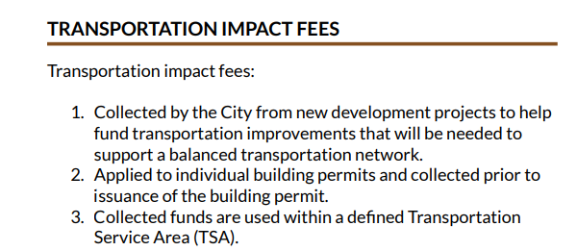
* *“In order to assess an impact fee, land use assumptions must be developed to provide the basis for residential and employment growth projections within a transportation service area. As defined by Chapter 395 of the Texas Local Government Code, these assumptions include a description of changes in land uses, densities, and development in the TSA.  
    
  The City completed a study to define these land use assumptions and subdivided the City into 21 TSAs. The land use assumptions are then used in determining the need and timing of transportation improvements to serve future development.”*
* 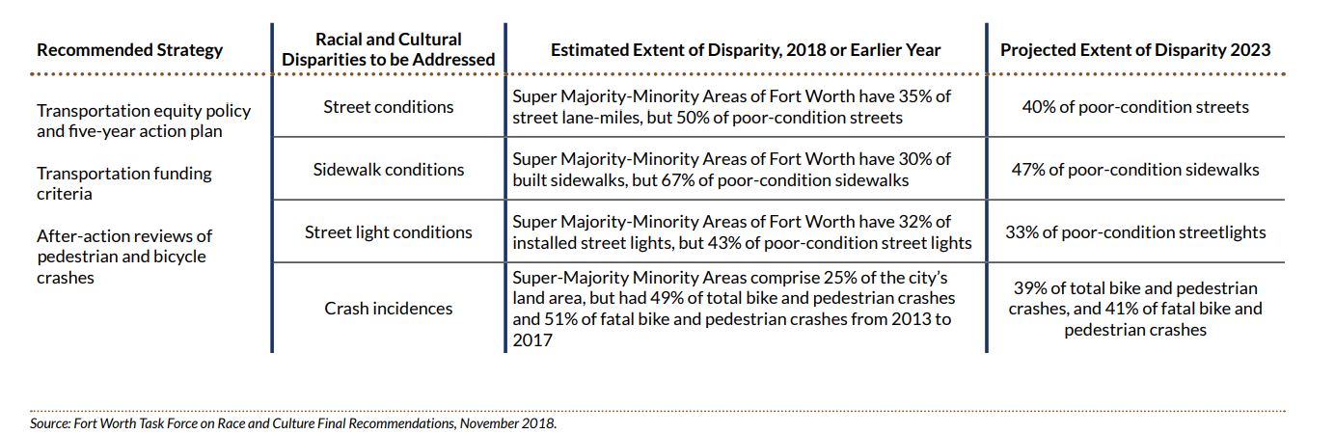
* *“The City of Fort Worth’s Race and Culture Task Force provided recommendations on disparities in majority minority areas, including the topic of transportation. The report found that Super-Majority Minority Areas (S-MMAs) of Fort Worth, defined as those census block groups that have a minority population of 75% or greater, have a disproportionate share of streets, sidewalks, and street lights in poor condition and are disproportionately affected by pedestrian and bicycle crashes, including fatal crashes. Three recommendations were proposed and a dashboard for tracking progress was created: 1. Adopt a Transportation Equity Policy and Five-Year Action Plan. 2. Change transportation funding criteria to emphasize S-MMAs. 3. After-Action reviews of pedestrian and bicycle crashes.”*
* *“Trucking companies could reduce costs by decreasing the number of drivers and taking advantage of platooning. In truck platooning, a lead truck sends wireless commands to one or more following trucks to regulate speed, steering, braking and distance between the trucks. Air drag is reduced, reducing fuel consumption by up to 15%. Safety distance between trucks can be reduced, thereby reducing highway congestion. Platooning could reduce the driver’s workload, or remove the driver entirely. This application is controversial because reducing the number of drivers will also affect many people’s livelihoods, as there are currently 3.5 million truck drivers in the US alone.”*
* *“A public school district or independent school district (ISD) is a school district that is separate from any municipality, county, or state—the school district has its own taxing authority outside the direct control of other governmental entities.”*

### 2025-01-22

#### Daily Summary

Today’s reading was the sections on arts and culture and the police department, ending with the intro to the section on the fire department.

FW invests heavily in artwork, and has interesting programs centered around partnering with other orgs to address needs of the mentally ill and homeless populations, which involves officers being deployed with case workers and other professionals.

There is mention of various community programs to get involved with FWPD, and regular mention of DEI, accountability, etc. Given the timing of this report, one wonders how much of this emphasis was due to the true nature of city feelings on these matters as opposed to public outrage around recent events.  
  
Ended on pg. 262.

#### Notes

* *“Since 2006, Fort Worth has utilized the National Incident-Based Reporting System (NIBRS) methodology for crime reports. NIBRS compiles detailed reports on two types of crime offenses: Group A offenses and Group B offenses. The two groupings are based on the amount of reporting required for each. Both incidents and arrests are reported for Group A offenses. Group B offenses are reported when an individual is arrested.”*

### 2025-01-23

#### Daily Summary

The Fort Worth Fire Department (FWFD) includes many teams such as fire, water rescue, emergency management/planning, air rescue, hazardous materials (hazmat) etc.

There are several programs for complying with regulations and monitoring land, air, and water quality in a variety of settings, along with managing waste and increasing energy efficiency

It struck me how much a city is like a mini-country in that it needs to prepare to handle and regularly perform every function that a nation would.

I wonder how much stronger a nation is in this case. Should national resources be compromised, there is redundancy in capabilities at the state and municipal level, that can keep society running.  
  
Ended on pg. 305.

#### Notes

* *“On March 1, 2017 Fort Worth Fire Department achieved an ISO Class 1 rating. Residents in ISO 1 rated cities can benefit from lower insurance costs.”*
* *“All drinking water begins with raw water supplied by the Tarrant Regional Water District (TRWD) from six lakes — Lake Worth, Eagle Mountain Lake, Lake Bridgeport, Cedar Creek Lake, Richland Chambers Reservoir, and Benbrook Lake. Adequate water treatment and pipeline capacity is crucial to protecting water quality in the lakes, streams, and rivers. The collection system has more than 3,565 miles of pipe, connecting to six regional lakes. Fort Worth owns Lake Worth, but the water rights belong to TRWD.”*
* *“Prior to construction, projects that are one acre or greater in scope or are part of a larger common plan of development are required to obtain a grading permit. The City reviews the stormwater pollution prevention plans (SWP3) and operator permits for these sites, as required by the TCEQ construction general permit. Sediment is the primary pollutant from construction sites, but other contaminants of concern include sanitary wastes, vehicle maintenance lubricants, concrete washout slurry, equipment fuels, and litter.”*
* *“Fort Worth has experienced significant change, both in population growth and land use, since it was incorporated in 1873. Land use has evolved with each decade, resulting in a diverse blend of industrial, commercial, and residential use throughout the city. Today, this trend continues, which places great emphasis on infill development to optimize use of land resources. The City strives to improve land quality for development by reducing pollution in soil, groundwater, and the built environment. The City works with community partners to address potential environmental contamination and to facilitate revitalization throughout Fort Worth, safeguard the public, and protect property.”*

### 2025-01-24

#### Daily Summary

Mostly covered municipal buildings and plans to improve them, started to cover capital improvement plans and instruments such as bonds used to finance them. Ended on pg. 333.

#### Notes

* *“Because the denser development pattern and mix of nearby uses favor pedestrian mobility instead of catering primarily to private automobiles, urban village developments make walking a fun activity again as well as an efficient and inexpensive transportation alternative within the urban village environment. Similarly, mixed-use growth centers provide an expanded area that may include one or more urban villages, while retaining the same mix of uses and walkable urban environment. Combining the mixed-use, higher density, walkable urban form of an urban village with a passenger rail station results in a transit-oriented development (TOD).”*

### 2025-01-27

#### Daily Summary

Outlining a neighborhood’s uses, street systems, and exterior design all impact how walkable, and appealing an area is amongst other economic impacts.

There are various policy methods for achieving desired neighborhood use and design.

There are also many federal, state and local funding tools for economic development, with the stated aim of not investing more than will be added in value by the (re)development of neighborhoods and properties.

Ended on pg. 357.

#### Notes

* 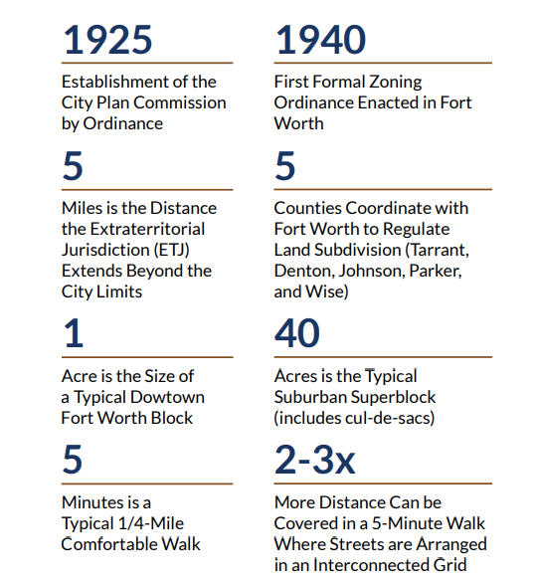
* *“The City uses the Zoning Ordinance to guide land development inside the city limits, but neither the City nor the pertinent counties have land use regulation authority in the extraterritorial jurisdiction (ETJ). Consequently, vacant lands within the City’s ETJ, outside the city limits, are being developed as suburban neighborhoods without the benefit of municipal land use control and infrastructure planning. This growing development trend results in the City’s leapfrog development, with suburban sprawl occurring far from existing City infrastructure and services.”*
* *“The Subdivision Ordinance provides for the recording of land subdivision plats with the county. A parcel must first be properly platted before a building permit can be issued. The City of Fort Worth requires decisions on easements and land dedications, including right-of-way and open space dedications, to be completed prior to the dedication of the plat. This benefits the plat applicant because it clears the path for a quick building permit approval.”*
* 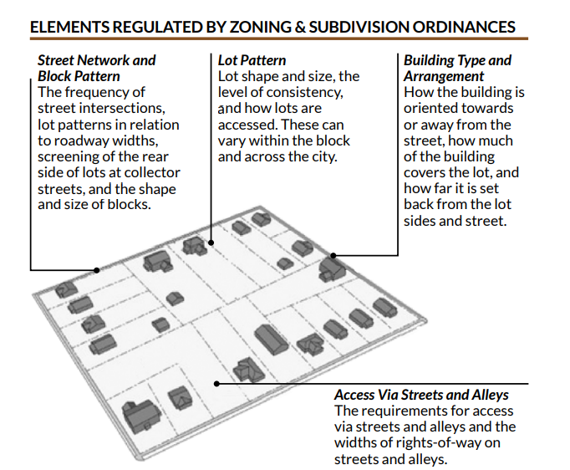
* 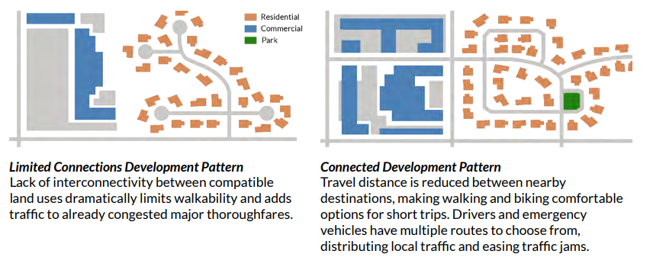
* 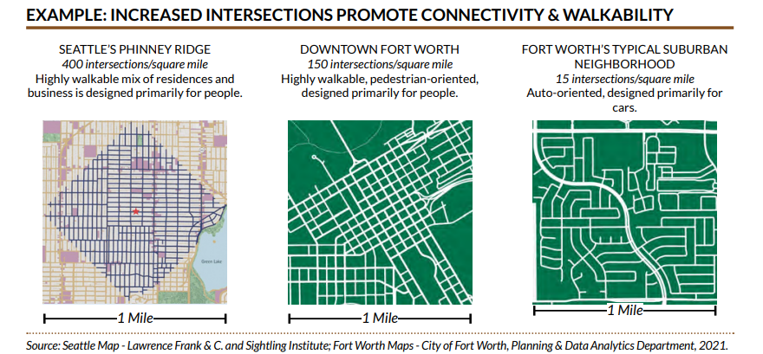
* *“As of January 2019, the city offers an additional expedited plan review service for building permit reviews. The “X-team” allows customers to schedule a meeting with a plan review team that includes senior plans examiners from all relevant city departments that can answer questions and identify issues on the spot, thus reducing the need for multiple rounds of submissions. This service is subject to additional fees beyond general building permit application fees.”*

### 2025-01-28

#### Daily Summary

The city annexes territory or trades territory to fulfill obligations or grow economically. It uses a lot of external funding from agencies to pursue goals, and coordinates with other municipalities in joint infrastructure efforts (e.g. rail lines) to promote economic development.  
  
The planning process seems to flow from departments > their different initiatives (programs) > and several plans within those initiatives (plans), which are then consolidated with similar efforts with other departments and/or organizations and finally rolled up to the citywide comprehensive plan.  
  
There are detailed development plans for all neighborhoods in one of the appendixes, though they are mostly copy-paste bullets on transit oriented development, economic development, and nature preservation. Ended on pg. 412.

#### Notes

* 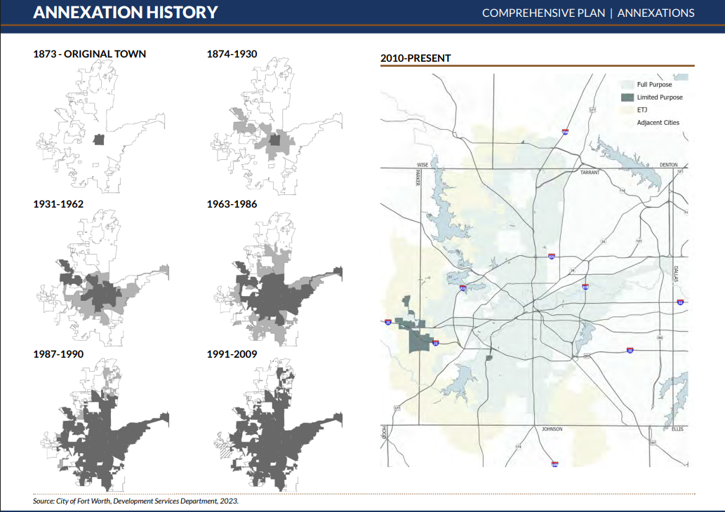
* *“Fort Worth should use annexation as an approach for alleviating jurisdictional conflicts with abutting municipal and county governments, and for coordinating service delivery arrangements with emergency response providers and municipal utility districts.   
    
  The City should consider requests for boundary adjustments from adjacent municipalities where an exchange of territories of equivalent value, or an exchange for other consideration of an equivalent value, could occur between cities. The requesting municipality should have adequate land use controls to maintain development standards equivalent to those of the City of Fort Worth. It can be anticipated that such adjustments will not be adopted if the area to be released would result in a reduction to the City of Fort Worth’s revenue stream or if the area contains environmental and economic resources vital to Fort Worth’s interests.”*
* *“The Trinity Railway Express commuter rail project was originally a joint venture of the City of Fort Worth and the City of Dallas. Each city owned a 50 percent interest in right of way formerly owned by Chicago, Rock Island, and Pacific Railroad that joins the two cities. The property was acquired to preserve the freight service until such time that mass transit could be re-introduced in the corridor. The cities of Fort Worth and Dallas have both transferred ownership of the rail corridor property to their respective public transportation providers, Trinity Metro and DART, who are responsible for implementing the Trinity Railway Express plan of services.”*
* *“The City of Fort Worth and the City of Dallas are joint owners of the Dallas/Fort Worth International Airport (DFW Airport), one of the busiest airports for both passengers and cargo in the world, making it an extremely important asset to the region.”*
* *“The Tarrant Regional Water District (TRWD) is a political subdivision of the State of Texas providing raw water resources to more than 70 wholesale customers across 11 counties in North Central Texas, including the cities of Fort Worth, Arlington, and Mansfield, as well as the Trinity River Authority of Texas. In addition to supplying quality water to its customers, the Water District also provides vital flood control along the banks of the Trinity River, preserves and protects the environment, and enhances recreational opportunities for the public.”*
* 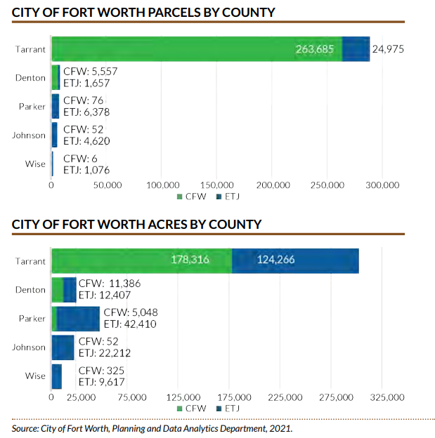

### 2025-01-29

#### Daily Summary

Annexation is a business exercise done in the interest of growth. Sources and definitions for further research can be found in appendixes. Finished reading doc.

#### Notes

* *“The City of Fort Worth seeks to annex property within its extraterritorial jurisdiction for the following purposes:   
  • To promote orderly growth by facilitating long-range planning for the provision of municipal services and by applying appropriate land use regulations, development standards, property maintenance standards, fire codes, construction codes and environmental regulations.   
  • To diversify the economic base and create job opportunities by annexing property for commercial and industrial development.   
    
  To fulfill these purposes, the City has formulated this annexation policy in order to:   
  • Provide the City Council with more specific, objective, and prescriptive guidance for making annexation decisions.   
  • Enable the City to be more proactive in identifying areas for annexation by providing for an annually updated five-year annexation program.   
  • Provide for meaningful public participation in formulating the annexation program as part of the annual update of the City’s Comprehensive Plan.”*
* *“Full Municipal Services – Services provided by an annexing municipality within its full-purpose boundaries, including water and wastewater services and excluding gas or electrical service. The City of Fort Worth provides the following services, including but not limited to: fire and police protection; emergency medical services; access to water and wastewater services unless such services are provided by another utility; solid waste collection; operation and maintenance of parks, publicly-owned facilities, and streets; library services; drainage and storm sewer maintenance; enforcement of environmental health, zoning and subdivision ordinances; enforcement of building and construction codes; and inspection services.”*
* *“2. Urban Development: The area meets all three of the following conditions:   
  a. The City is aware of or anticipates development activity of an urban nature in the area, with preference given to non-residential development or uses; and   
  b. The City is able to provide adequate municipal services upon annexation in accordance with State law, without negatively impacting service provision within the city; and   
  c. The City has determined through an appropriate analysis of prospective revenues and expenditures, as described in Section V (Preparation of Fiscal Impact Analysis) below, that cumulative revenues will exceed cumulative expenditures for each affected budget fund over the 10-year period immediately following annexation, or over a longer period as appropriate for long-term development.”*
* 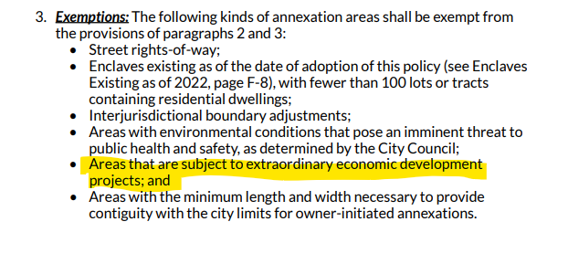
* *“For any proposed annexation, the Planning & Data Analytics Department, in cooperation with other pertinent departments, shall conduct a fiscal impact analysis that considers prospective revenues and expenditures for both the General Fund and the Water and Sewer Fund. Planning & Data Analytics shall prepare a fiscal impact report for review by the City Council, and shall make such report available for public review upon request.”*
* *“Relationship to Comprehensive Plan and Capital Improvement Program: The Comprehensive Plan is a general guide for making decisions about the City’s growth and development. It presents a broad vision for Fort Worth’s future and describes major policies, programs, and projects to realize that vision. The Comprehensive Plan contains both the annexation program and the capital improvement program as appendices. These programs are revised as part of the annual update of the Comprehensive Plan.”*
* *“Master Plans – Plans that are developed by individual departments within the City of Fort Worth and by individual agencies that provide greater detail than the Comprehensive Plan concerning departmental plans for future development and service needs. Master Plans generally detail anticipated services and general locations for public facilities such as schools, parks, libraries, and fire and police stations”*
* *“North Central Texas Council of Governments (NCTCOG) – The regional planning agency for the Dallas/Fort Worth area. The agency assists local governments in the 16-county region in coordinating sound regional development, encouraging cooperation for mutual benefit, and planning for common need.”*
* *“Policy – A predetermined directive of the City Council designed to guide thinking, decision making, and actions of decision makers and their subordinates in implementing goals or stated missions. Once a policy is adopted, it helps support or guide the creation/change of specific rules or strategies (such as development regulations, budgets, or supplemental plans). For purposes of the Comprehensive Plan, policies should be directly linked to stated goals. Policies are intended to guide implementation.”*
* *“Program – A formalized, defined strategy which has been authorized, funded, and/or designed for specific purposes. Can be long-range ongoing programs such as the national Low Income Tax Credit program or short-range, locally initiated programs.”*
* *“Project – A specific work-oriented program that has been created to achieve special purposes and has narrowly defined scopes and time frames.’*
* *“Real Gross Domestic Product (Real GDP) – Real GDP is the sum-total economic output produced in a given year’s values at a predetermined base market price. The Perryman Group references 2012 as the base year. The real GDP takes inflation into account and is also called inflation-adjusted GDP. Real GDP is the industry standard for exploring economic growth across multiple years.”*

## City of Fort Worth website - Fort Worth History page

### 2025-01-30

#### Notes

* *“The fertile, game-rich land surrounding the banks of the Trinity River had long been a favorite hunting ground for Native Americans in the area, but it soon proved irresistible to settlers as well.   
    
  A settlement had been established by Jonathon Bird in the winter of 1840, three miles east of where Birdville is today. In 1843, Sam Houston came to what was then called Fort Bird or Bird’s Fort and remained more than a month, awaiting chiefs from different tribes to discuss a peace parley. Houston departed, leaving Gen. Edward H. Tarrant and George W. Terrell to meet with the chiefs. When the tribes came to the negotiating table, a treaty was made under which the Native Americans were to remain to the west of a line traced passing through the future site of Fort Worth. The line marked “Where the West Begins” — giving Fort Worth its famous slogan."*
* Although the city of Fort Worth is named for the U.S. Army fort established in 1849, its history begins with the earlier settlement at Bird's Fort in 1840, three miles east of present-day Birdville  
    
  This settlement was founded only 4 years after Texas gained its independence from Mexico in 1836, in a fight that was preceded by longstanding tensions between the former state and Mexico, exacerbated by the Mexican government overturning its founding constitution of 1824, and moving to take power away from the states.  
    
  It would be another 5 years after the formation of Bird’s Fort before the United States would annex Texas.
* The settlement later became more formalized with a treaty with native tribes who agreed to stay West of the area.
* The establishment of the Fort was a result of the us military attempting to gain control of the region, and establishing forts along the new territory.
* *“A small civilian community grew up in the comforting shadow of the fort. No more than 100 people lived in the vicinity, most of whom were more dependent on the garrison for economic well-being than safety. Farther out from the bluffs, the county created by the state legislature in 1849 — Tarrant — also began filling up with homesteaders attracted by the rich soil and the security provided by the U.S. Army. In the next four years, the number of settlers grew to some 350 hardy souls.  
    
  On Sept. 17, 1853, the fort was vacated. Troops were redeployed as the line marking the Western frontier made another push toward the Pacific Ocean.”*
* Fort Worth’s economic success is inextricably linked to its natural resources, historical forces, and aid from the federal government.
  + The settlement was on “fertile, game rich land” and near a river.
  + The earliest populations of both Fort Worth and Tarrant County came under the protection of the US army, and benefited economically from the military outpost, starting the longstanding relationship between Fort Worth and the US military.

### 2025-01-31

#### Notes

* The role of institutions should not be overlooked here. The 2024 Nobel Prize in Economics was awarded to three researched who showed the role of non-extractive institutions in economic success of a Country. Nogales is given as an example in this video, which may as well be Fort Worth for all its similarities. A while back, I read: *¿Y ahora qué? México ante el 2018*, and many of the chapters reflected on the role of poor rule of law, social welfare, and legal institutions (including corruption at all levels of government) in poor social outcomes, and decreased investment and development in Mexico at the time of its writing.
* *“Great herds of Longhorns were driven from Texas to the railheads in Kansas; and Fort Worth was on the main route — the Chisholm Trail.”*
* The settlers of Fort Worth also chose a location which was in the middle of the booming cattle industry. Cattle had arrived in Texas in the 1690s from Spain, and ranching was occurring when they arrived. As Fort Worth was getting going, cattle were a huge industry, with over 200,000 cattle driven to the north in the mid 1800’s.
  + Museum photo
* *“In any event, the first train entered Fort Worth July 19, 1876. The race had been won. People came from miles around; on horseback and in wagons to see the train pull in. Many had never seen a train before.”*
* *“The arrival of the railroad changed Fort Worth from a waypoint along the cattle trail to the goal of the drives. Cattle pens were built and the city became the shipping point.”*
  + *Museum photo*
* Pens were built following the first railroad, and in 1889, a large stockyard was built. Through the 1950s, livestock was big business in Fort Worth. Starting in 1905, the Fort Worth livestock market was the biggest in Texas and the Southwest, and ranked among the top 4 in the nation.
* *“One of the chief factors in the development of Fort Worth has been strong and progressive banks. In 1870, Capt. Martin B. Loyd opened an “exchange office” that evolved into the First Bank, chartered in 1877. Thomas A. Tidball and John Wilson, in 1873, opened a private bank. A year later, Maj. Van Zandt, John Peter Smith and Maj. J.J. Jarvis purchased Wilson’s interest and the name was changed to Tidball, Van Zandt and Company. In 1884, Noah Harding, Col. R.L. Ellison and Dr. E. Beall acquired interests in the institution and it became the Fort Worth National Bank. The Continental National Bank was established in 1903 with J.G. Wilkinson as president. Chairman of the Board was Morgan Jones, the contractor who built the T&P into Fort Worth. The Continental National was one of the first banks in this section to lend money for oil development, and it has long been known as “an oil man’s bank.””*
* *“Polytechnic College was founded in 1890. It became Texas Women’s College in 1914 and, 20 years later, it again became co-educational as Texas Wesleyan College. It is known today as Texas Wesleyan University.”*
* Here again, we see institutions springing up and playing a pivotal role in the development of the City of Fort Worth and its economy. With the security afforded by the new nation and state’s militaries, booming native industry like cattle, and with investment from banks for oil exploration, the was kindling for a boom.
* A note for later: Raw ingredients (oil, a river, grasslands for grazing), met with institutions (US military, banks, local governments, early colleges), met with hard work (bringing in a railroad, winning gov contracts), and historical luck (world wars that were an economic boon for the US and FW) to produce our current economy.   
    
  The left-over railroads and airports from cattle and military work + open land and our geographic location (economic development plan states open land and proximity to Mexico and most of the US) fostered our warehousing and logistics industries.   
    
  The military industry is rooted in longstanding relationships from the inception of Fort Worth through the world wars, and the oil industry was one of the industries that **made** Fort Worth. And so, in a way, you can say Fort Worth’s economy and its development are the result of industries creating a city, and not the other way around. What our predominant industry(s) can/will be in the future is to be determined.

### 2025-02-03

#### Notes

* *“The Board of Trade, of which W. A. Huffman was the first president; was responsible for the organization of the Fort Worth Dressed Meat and Provision Company, with capital stock of $500,000. Stock yards and the packing plant were built and the business started.  
    
  Swift & Company, Armour & Company and McNeill & Libby packing houses all came to Fort Worth in 1902.  
    
  This development lacked the dramatic features of the arrival of the first train, and of the passing through of the cowboys and the trails herds but, in its significance, it rivaled any previous event in the city’s history. Fort Worth became the packing house center of the southwest.  
    
  Employment for thousands resulted and the payroll of the packing houses has been a great factor in the prosperity and progress of Fort Worth ever since. The full impact of the packing houses was revealed in the 1910 census figure: 76,312, an increase in of almost 300%.”*
* Between packing houses coming to Fort Worth, and the first world war, the Wright brothers take their first flight in 1903
  + Cowtown takes flight photo
  + Airmail. The US pays/invests into aviation tech during WW1. Cowtown takes flight photo
* *“The Fort Worth Gas Company was organized in 1909 and began serving 3,840 customers by means of a 90-mile pipeline from Petrolia.  
    
  A combination of war and oil gave Fort Worth its next great impetus.  
    
  World War I broke out in 1914 and, three years later, the Canadian government established three flying fields in the vicinity of Fort Worth. The mild climate made year-round training possible.  
    
  Seven thousand workers constructed the fields: Taliaferro 1, 2 and 3. In Greenwood Cemetery is a plot where 11 members of the Royal Flying Corps and the daughter of an enlisted man are buried. A monument bears the names and a tribute to the gallant dead. The ground belongs to the British Government and, because of the brave men resting there, it is “a spot that is forever England.”  
    
  When our nation entered the war, the fields were taken over by the United States, and two were renamed Carruthers and Barron. Camp Bowie was built here in 1917 at a cost of more than $3 million. More than 5,000 workers erected 1,500 buildings on the 1,410 acres. The 36th Division (Texas and Oklahoma) trained at Camp Bowie. The total military payroll was $1,675,000 a month, and 1917 showed an increase of $10 million in bank deposits over the previous year.”*
  + *Cowtown takes flight phot: Ben E Keith*
  + During the oil boom, Neiman Marcus in Dallas was able to grow, selling luxury clothes to rich oilmen
* *“Fort Worth, strategically located between the two areas, experienced an oil boom, too. The Westbrook Hotel lobby was the center of the activities. All the chairs were removed to make room for the throngs of operators, promoters and speculators. Even then, there was not sufficient space, and the sidewalks were so packed that one could hardly get in or out of the hotel.  
    
  Even before the rush, Fort Worth had three refineries. By the late summer of 1920, five others had been built, with four more under way. This, along with a network of lines made Fort Worth “The pipeline center of Texas.” Bank deposits soared; big office buildings were erected, and beautiful homes were built from the riches that gushed out of the ground.”*
* Railroads, highways, and aviation were all largely subsidized by the federal government in pursuit of its own economic development and defense goals. Fort Worth’s history and economic landscape was not only shaped by its natural resources, timing, and local entrepreneurs, but by massive monetary investment by the federal government coming both in the form of direct investment (land grants, railroads, roads, aviation investment and military contracts), but also by federal military protection, and federal state and local institutions which set the stage for the long term security, rule of law, and community investment that are prerequisites for economic growth and prosperity.